Randolph Community Forest

Stewardship Plan

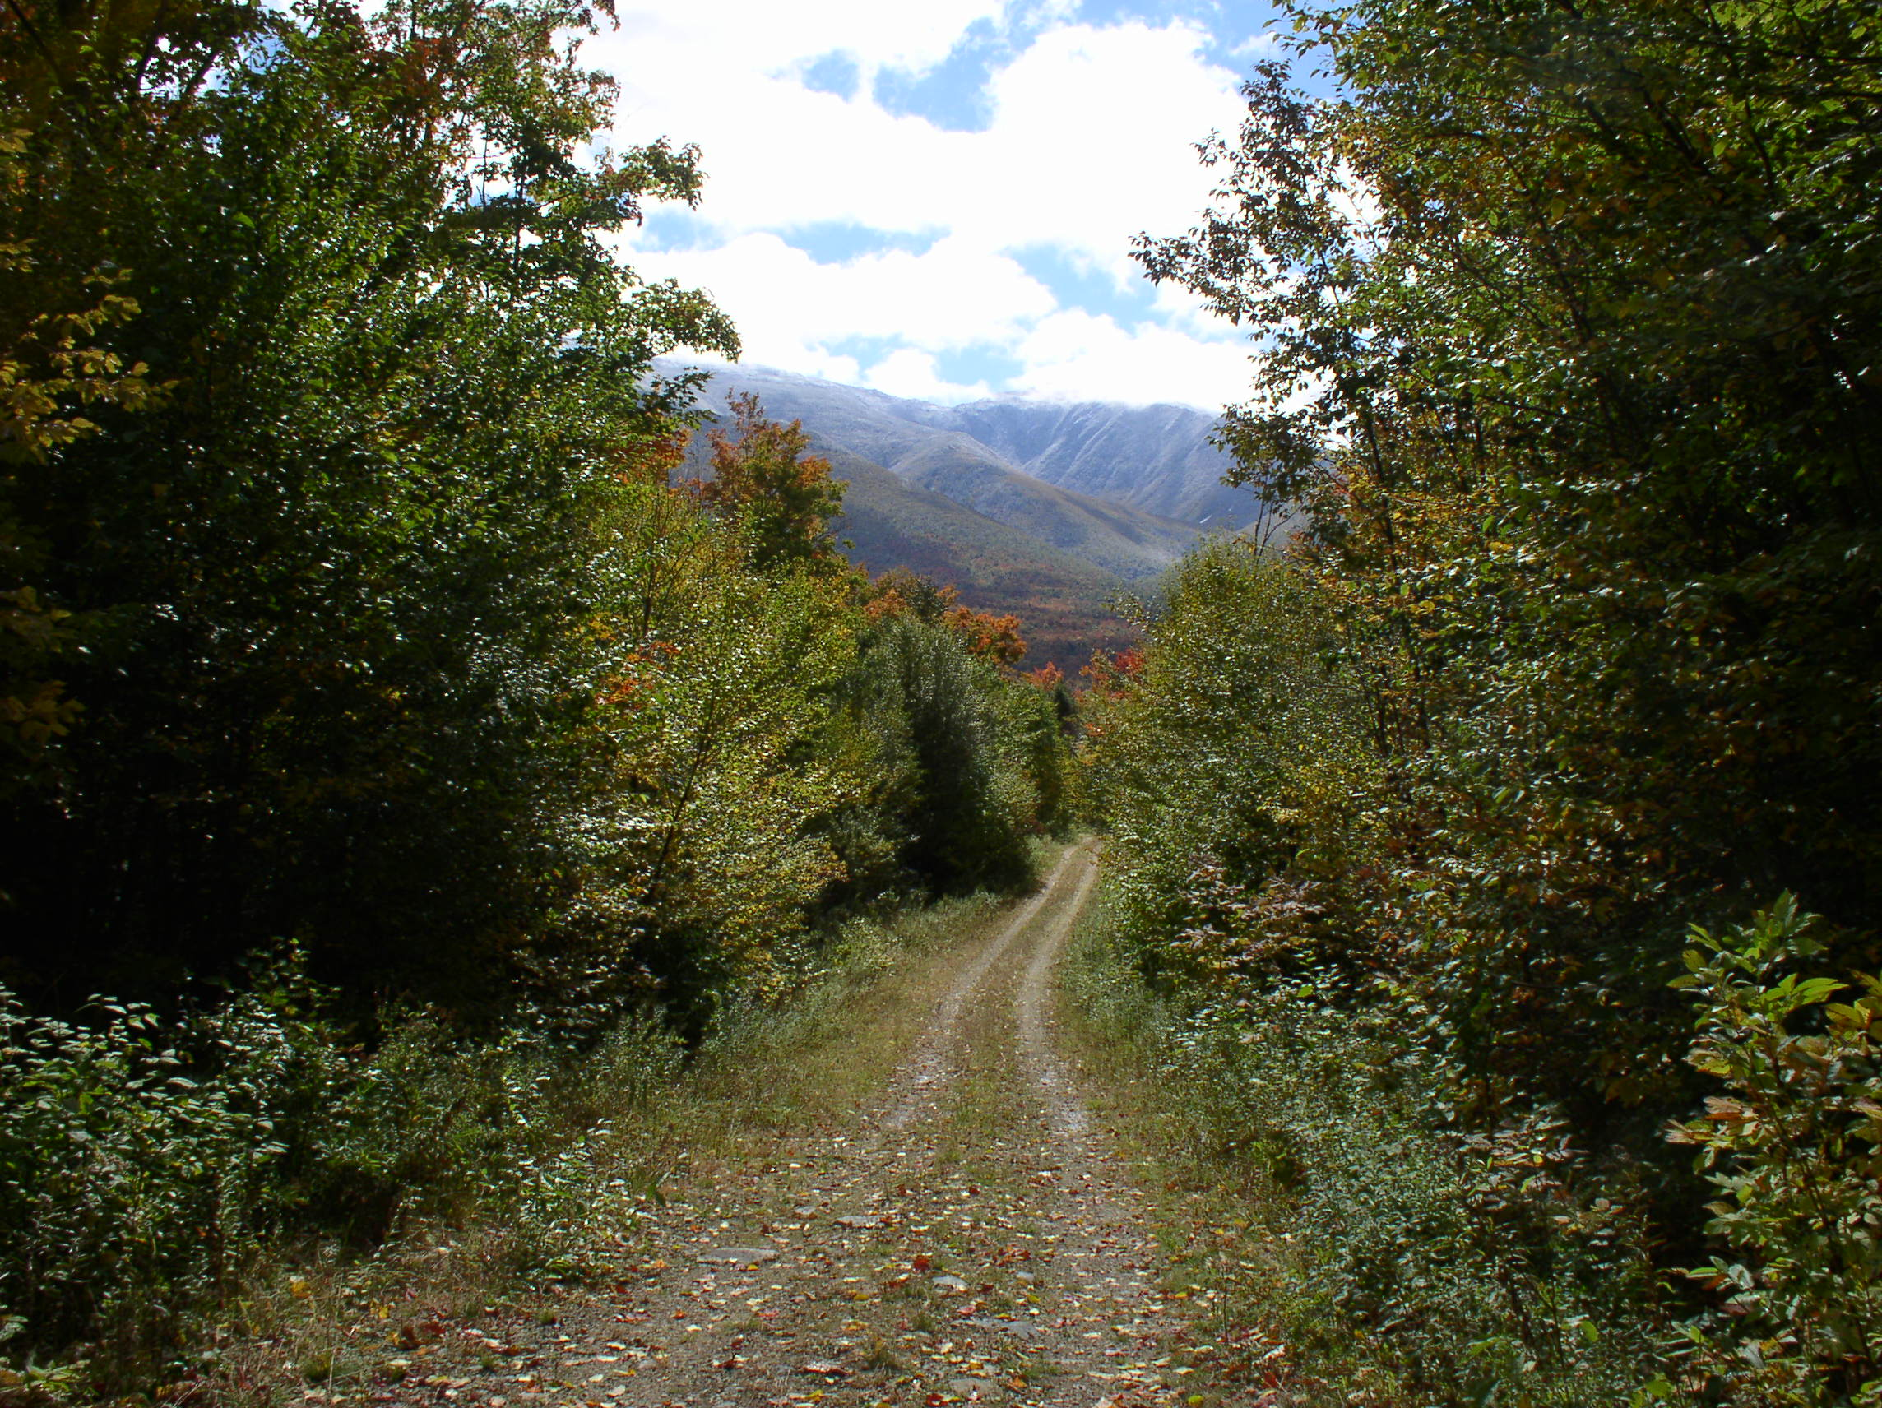

November 17, 2003

Prepared for:
The Randolph Forest Commission
Town of Randolph
Randolph, NH

Prepared by:

Walter Wintturi, Forester #345 Watershed to Wildlife, Inc.
41 Mechanic Street 544 Jefferson Road
Gorham, NH 03581 Whitefield, NH 03598

table of contents

I. PURPOSE…………………………………………...…………………………….. | 4
II. FOREST STEWARDSHIP GOALS……………………………………………. | 4
III. FOREST RESOURCES…………………………………………………………. | 6
Compartments...………………………………………………………………... | 6
Forest History……………...…………………………………………………… | 6
Geology…………………………………………..…………………………….. | 8
Soils……………………………………………………………………………. | 10
Road System………………………………..………………………………….. | 13
Water Resources……………………………………………………………….. | 16
Wildlife Habitat………………………………………………………………… | 20
Rare Species and Exemplary Natural Communities…………………………… | 26
Visual Resources……………………………………………………………….. | 27
Recreation……………………………………………………………………… | 28
Forest Protection……………………………………………………………….. | 30
Timber………………………………………………………………………….. | 31
IV. ACTION PLAN …………………………………………….…………………... | 47
V. FUTURE OPPORTUNITIES………..…………………………………………... | 50
MAPS…………………………………….……………………………………………. | 52
REFERENCES………………………………………………………………………… | 63
APPENDIX A - GLOSSARY……………………………………………….………... | 64
APPENDIX B – RARE SPECIES AND COMMUNITIES FROM NATURAL HERITAGE INVENTORY AND NH FISH AND GAME.………………………... | 69
APPENDIX C – COMPARTMENT REPORTS…………………………………… | 73
APPENDIX D - HISTORY OF THE PROJECT…...………………………………. | 100
APPENDIX E – GRANT OF CONSERVATION EASEMENT…………………... | 104
APPENDIX F – SNOWMOBILE AGREEMENT…………………………………. | 115
APPENDIX G – LAND USE ORDINANCE……………………………………….. | 118

I. Purpose

This plan has three purposes:
- to meet the requirements of the Conservation Easement between the State of New Hampshire, Department of Resources and Economic Development, and the Town of Randolph, New Hampshire
- to document the state of the resource situation within the Forest as it exists in 2003. Since the history of this land area influences future actions, it too will be described
- to develop an action plan section that will list the proposed actions for timber, road, wildlife and recreation management.

The plan will be revised every ten years, with an updated action plan for the next ten year period. This plan should provide a foundation for future plans to tier to the resource section, where, with the exception of the wildlife and timber resources, little change is anticipated.

II. Forest Stewardship Goals

The Forest is managed by a five member Commission that, based on public input, developed the following management goals:

Forestry Practices

It is a long-range goal of the Town to encourage the growth of high quality saw timber products wherever the soils are suitable and other ecological conditions are favorable.
It is the Town’s preference that all harvested tracts of land be irregular in shape for aesthetic purposes, so far as that can be accomplished considering natural boundaries, soil types and other relevant forest management considerations. Forestry practices will be in accordance with the Conservation Easement, the recommendations of “Good Forestry in the Granite State,” and best management practices (BMP).
Public hearings will be held annually whenever harvesting projects are proposed to discuss such projects and provide an opportunity for public comment. If such projects would abut private property holdings, the owners of such holdings will receive written notice of the relevant public hearing.

Income Considerations

It is a long range goal of the Town to earn profits from timber harvesting over and above that needed to cover forest management and maintenance costs and use such profits for the benefit of the Town.
It is a short term goal of the Town to earn a sufficient amount of income from timber harvesting to cover the PILT payments to the Town of Jefferson, the costs incurred for road and boundary maintenance, mowing, forestry and wildlife management and other expenditures related to the running of the Community Forest, and – after such other costs are covered – payments to the Town in lieu of timber and property taxes.

Aesthetics

It is a goal of the Town to encourage the use of harvesting techniques which minimize the visual impact of timbering activities (“light harvesting”), in those areas of the Community Forest, such as the southern slopes of Mount Crescent, which are easily seen from the Randolph Hill Road, Route 2 and the Presidential Range. In all areas of the Forest timber harvesting will be conducted utilizing best management practices as required by the Conservation Easement.
It is also a goal of the Town to encourage the creation and maintenance of appropriate viewing spots or outlooks on existing recreational trails and maintained roadways.

Recreation

It is a goal of the Town to encourage the preservation and maintenance of existing recreational trails for both summer and winter use by the public. The development of new trails will be carefully considered.
It is a goal of the Town to see that trails are designed and maintained utilizing Best Management Practices (BMP) to protect soils from erosion or other forms of degradation and to avoid undue disturbance to the habitats of plants and animals.
Hiking trails shall be used only by pedestrians for foot travel, snowshoes and cross-country skiing. The use of the Community Forest by the public for recreation purposes shall be consistent with the terms of the Conservation Easement and the Snowmobile Agreement attached to it.

Ecology

It is a goal of the Town to promote the development and maintenance of open areas and other conditions within the Forest which are designed to encourage the proliferation of various species of wildlife, but to do so in a manner which will protect scenic, recreational and botanical values. Forest type and age composition will be managed to increase the amount of aspen, spruce/fir and extended rotation, northern hardwood stands.
It is a goal of the Town to encourage plant and animal diversity where consistent with the achievement of the other purposes set forth in the Conservation Easement and where such diversity within the Randolph Forest will contribute to a healthy mix of natural communities in the larger region of which it is a part.
It is a goal of the Town to ensure that water resources, streams and wetlands are protected by the utilization of best management practices as laid out in the Conservation Easement.

Roads

It is a goal of the Town to maintain the Pond of Safety Road in a condition which enables it to be used by high clearance vehicles to access the Pond of Safety and the regions around it. It is the intention of the Town to keep the gate to the road open for public access except when its temporary closure is needed to protect the condition of the road or to deal with emergencies. Parking facilities will be developed as required.
It is a goal of the Town to identify a network of roads in the Forest which can be utilized for emergency access and to keep such roads maintained in a condition which makes such access feasible.
It is a goal of the Town to identify a somewhat larger network of roads which may be useful for future timber harvesting operations and to close those not required for emergency access but maintain the road beds in a condition which makes it relatively easy to reopen them. This may include the periodic mowing of roadbeds, especially where it is likely to provide habitat for wildlife.
It is a goal of the Town to close roads not needed for timber harvesting or other purposes.

Education

It is a goal of the Town to use the Forest to educate residents and members of the public about the natural cycles of forest life and about the role that sustainable timber management can play in the Community Forest.
It is also a goal of the Town to use and encourage the use of the Forest as a laboratory where experiments can be carried out relating to sustainable timber management, wildlife habitat enhancement, soils protection and other relevant subjects.

III. Forest Resources

1. Compartments

In order to facilitate resource analysis, information management and record keeping, the 10,000 acre forest area was sub-divided into eight compartments. This sub-division was based on watersheds, topography, and the road system within the watershed. Compartments 1A&B and 2A&B are within the Stag Hollow Brook watershed. Refer to Maps, page 52. Compartment 3A is in the Israel River watershed. Compartment 3B is in the Moose River watershed and Compartments 4A&B are within the Moose Brook watershed. This breakdown showing the compartment boundaries and their size is illustrated on Map 3. It is the same sub-division that Charles Baylies and Peter Farrell used in their Stewardship Plan (Baylies, Farrell 2001).
The following resource descriptions will refer to these compartments when they are being described. There are some resource features that are unique to an area within a particular compartment.

2. Forest History

Little has been documented about early logging in the Randolph Community Forest (RCF), that is to say, logging that occurred one hundred years ago or earlier. One hundred years ago market demand and log transportation technology more or less limited harvesting to spruce, fir and white pine. Logs harvested from the forest were most likely removed during the winter on sled roads. The streams are not large enough to support log drives and there is no evidence of railroad grades. Francis Belcher in his book Logging Railroads of the White Mountains makes a general reference to logging in the Stag Hollow brook drainage during the 1870’s including it with other logging that occurred along the railroad built between Whitefield and Berlin through Jefferson and Randolph. Spruce/fir was harvested in stands along the brook and brought by sled to the railhead at the junction of Route 115 and the railroad grade (Clukay, 2001).
Rev. Robert Hatch described the logging in the Forest that occurred during the late 1930’s. It is surmised that this was prompted by the 1938 hurricane that blew over trees on exposed slopes. He said in 1940 he purchased the camp office building that had been used by the Brown Company along the Vyron D. Lowe Trail. They closed the camp that year and he took over the building to use as a hiking shelter. During the 1940’s and 50’s the Brown Company also had a camp along Stag Hollow Road approximately 0.7mile east of the gate, compartment 2B, stand 15. Refer to Map 6. Logs now could be trucked to sawmills and the pulp mill which meant that hardwoods which are the major timber resource of the RCF could be harvested. During the late 1940’s and 1950’s a second logging camp was established in the Unknown Brook drainage (Neal, and Potter, 2003). Timber harvesting also occurred upslope from Bowman during the 1930’s and 40’s (Neal, 2003).
During the 1960’s Brown Company contracted with Gerard LeBrecque to harvest timber in Stag Hollow including the Pond of Safety area. The terms of this contract were fairly general regarding the designation of trees to cut so essentially it was “logger’s choice”. During the late 60’s and into the 70’s timber sale contracts were prepared and supervised more directly by Company foresters resulting in improved stand management. Even during the late 60’s some of the stands contained large hardwood trees that were designated for cutting (Grella, 2003).
In 1980 ownership of the land changed Companies as the pulp and paper mill was sold to James River Co. The Forest remained under the management of foresters that had worked for Brown Co. During this era the timber sale contracts and sale administration was more controlled by foresters. Some stand treatments were stand clear-cuts while others were thinnings or uneven-age management single tree selection cuts.
In 1993 ownership of the land changed once again when it was transferred to the Hancock Timber Resource Group (HTRG). Foresters continued to prepare and administer timber sale contracts. In 1998 a devastating ice storm impacted much of the area on the east side and upper elevation stands of the Forest. The HTRG response was to clear-cut harvest as many stands as possible to utilize timber before its quality deteriorated. This harvesting was done during 1998-99 ceasing in 2000 when they agreed to sell this tract to the Trust for Public Lands.
Nothing has been documented about forest fires occurring within the Forest. However, charcoal from past burns has been found in various places throughout the Forest. These fires do not appear to have been intense enough to affect the long term productivity of the land. They were the result of lightening caused fires years ago or caused by carelessness at old woods camps.

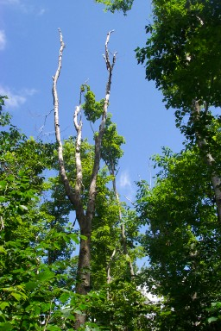
Evidence of ice storm damage in the Forest.

In summary, this history discussion sets the stage for future management. For over one hundred years it has been managed as an industrial forest; rather intensely during the past fifty. Almost all of the stands were entered for tree removal at least once and some more than once. Few stands are adequately stocked to support a thinning or are old enough to justify a regeneration cut. The ’98 ice storm resulted in approximately 10% of the area, plus or minus, being in the regeneration age class. It also resulted in several poor quality stands because damaged crowns have reduced potential growth or made the trees likely to die within the next ten years.

3. Geology

Geologic events that occurred thousands and millions of years ago still influence the management of the forest today. Parent bedrock material that was formed millions and hundreds of million years ago provide the nutrients for vegetation today and to some extent determine which species will grow where on the forest. The last glacier broke apart, transported and dumped or deposited the material in a way that has an even stronger influence in what species will grow where on the forest. The glacier also has an influence on the management options that are available today.
An era of granitic intrusions in this area occurred around five hundred million years ago. This was followed by a period of sedimentation and then plate tectonic shifts that metamorphized this material forming a rock, Olivarian granite that would weather relatively easily and break down into soil particles. During a period one to two hundred thousand years ago another granitic intrusion, the White Mountain magma series occurred. This material was not metamorphized and due to the way it formed and cooled, formed quartz particles that resist weathering and breaking down. The oldest bedrock is found in the middle and west portion of the forest, compartments 1A&B, 2A&B, 3A. Refer to Map 3. The more recent material is found in the vicinity of Mt. Crescent and the Pilot Range to the north. The Olivarian granite contains more of the base cations, calcium, magnesium and phosphorus and provides these nutrients to the soil primarily on the west half of the forest. The granite formed during the White Mountain magma series breaks down and weathers into a coarser soil that does not provide as much nutrients as the soils on the west half of the forest.
Fifty thousand years ago the Wisconsin stage of glaciation began. This glacier ground and transported bedrock and soil material in its path in a southeasterly direction from its origin. It also homogenized bedrock material somewhat, mixing the various materials together. It transported the rock and soil material, till, approximately 3-5 miles, 10-20 miles at most. According to a glacial drift model developed by Dr. Scott Bailey, a geologist at the Northeast Forest Experiment Station, Hubbard Brook, the ridge of high ground from Lookout Ledge to Mt. Randolph and on northward marks a divide between a higher index of calcium, 2.0-2.4, to the west, compartments 1A&B,2A&B,3A, and less calcium, 1.7-2.0 to the east, compartments 3B, 4A&B. Refer to Map 3. This is apparently due to the calcium that is available from bedrock material.
Approximately 10 to 15,000 years ago the glacier began to recede. Over the area of the forest, the glacier simply dumped much of its material in place. That is to say there was not any sorting or rearrangement of soil or rock, it simply melted down to the bedrock beneath it. This is described as a fine till that contains a mix of particle sizes from rock fragments to sand and silt particles (Leak, 1978). Over much of the forest area the fine till was deposited on top of a hard platy layer or hardpan. The hardpan is often impervious to water draining through it or tree roots growing into it. Dry compact till habitat forms a rolling, ridge-like, or convex topography. This is present over most of the forest and supports the northern hardwood cover type of sugar maple, beech and yellow birch. A wet compact till that forms a flat or depressed topography is also present especially in the Stag Hollow Brook drainage. It is this area where spruce-fir type grows.
Along Stag Hollow Brook, glacial melt waters sorted soil particles into different layers according to size. This is one of two areas of outwash habitat on the forest. The other is along the upper reaches of Great Ledge Brook. Refer to Map 5. This too supports a spruce-fir cover type.
The final habitat type attributed to the glacier is the washed till habitat. This was till rinsed by water causing much of the fine soil particles to be carried away by glacial melt-water. Some of this habitat is found on the lower slopes of the forest. Beech, red maple and paper birch are found on this type.
In summary, the bedrock and resultant soil formed during past geologic periods together with the transport and deposition of this material by the glacier is a strong influence on the trees, shrubs and herbaceous vegetation that grows on the forest. The most influential is the type of till or outwash that was deposited, and whether or not the till lies on top of a hard pan layer. Sugar maple, beech and yellow birch grow on the fine till and dry compact till soil; beech, paper birch and red maple grow on the washed till; spruce-fir grows on the outwash and wet compact till sites. These are the species best suited to these respective habitats and whose regeneration and growth will be promoted.

4. Soils

An analysis of the soil types reveals that over 95% of the forest area supports the forest management objective to grow high quality saw timber products. Most of the soils are sandy loams or fine sandy loams, fine till, which are well suited to the growth of sugar maple, yellow birch and white ash. Approximately 17% of the soils are either a coarse or fine washed till where beech, red maple and aspen will grow well. About 40% of the soil is a dry compact till where red maple, yellow and paper birch, and beech are more productive. Approximately 35% of the soil is a fine till where sugar maple will do best. About 8% of the soil is a wet compact till or outwash limited to the immediate vicinity of Stag Hollow Brook. Softwood stand management is limited to these soils. Refer to Maps 4 and 6.
Approximately 95% of the forest land area is underlain by a hardpan/dense basal till. This pan layer slows or limits the drainage of water down through the soil horizons keeping the soil moist to wet especially in the spring, fall and winter. This may be beneficial to tree growth keeping available water high for tree growth during the growing season. However, an implication is that equipment operations on this ground is limited to winter or the months of July, August or early September provided the weather is dry, not rainy. Another implication is that road maintenance costs will be higher to insure that culverts ditches and waterbars are functioning to handle the potential increased run-off.
Research has shown that species composition and productivity vary among 11 forest habitat types defined for areas of granitic drift in the White Mountains (Leak 1978). These forest habitat types are correlated with soil associations described by the Natural Resource Conservation Service. Table 1 illustrates the percent by area of habitat types within each compartment, the corresponding soil series, and the predominant tree species supported by the type.

Table 1: Summary of Soils throughout the Randolph Community Forest
Compartment | Soil Series | Forest Habitat Type | % of area | Predominant species
1A | Marlow-Peru  Peru-Marlow  Pillsbury-Peacham-Marlow  Monadnock | Dry compact till  Fine till over compact till  Wet compact till  Fine washed till | 67%  20%  7%  5% | Red maple, birches, beech  Sugar maple, beech, y. birch  Red spruce, b. fir  Red maple  Beech, y. birch
Compartment | Soil Series | Forest Habitat Type | % of area | Predominant species
1B | Pillsbury-Peacham-Marlow  Peru-Pillsbury  Sheepscot | Wet compact till  Fine till  Outwash | 65%  20%  14% | Red spruce, b. fir, red maple  Sugar maple, beech, y. birch  Red spruce, b. fir
2A | Monadnock-Hermon  Marlow-Peru  Waumbek-Hermon  Skerry-Peru  Pillsbury-Peacham-Marlow | Fine washed till  Dry compact till  Course washed till  Fine till over compact till  Wet compact till | 40%  18%  21%  14%  6% | Beech, y. birch  Red maple, birches  Beech  Beech, P.birch, red maple  Sugar maple, beech, Y. birch  Red spruce, b. fir, red maple
2B | Peru-Pillsbury  Peru-Marlow  Marlow-Peru  Pillsbury-Peacham-Marlow  Waumbek-Hermon | Fine till  Fine till over compact till  Dry compact till  Wet compact till  Course washed till | 40%  14%  29%  11%  6% | Sugar maple, beech, y. birch  Sugar maple, beech, y. birch  Red maple, birches, beech  Red spruce, b. fir, red maple  Beech, p. birch, red maple
3A | Tunbridge-Lyman-Marlow  Peru-Marlow  Peru-Pillsbury | Dry compact till  Fine till over compact till  Fine till | 40%  34%  24% | Red maple, birches  Beech  Sugar maple, beech, y. birch  Sugar maple, beech, y. birch
3B | Peru-Marlow  Becket-Skerry  Monadnock-Hermon | Fine till over compact till  Dry compact till  Fine washed till | 45%  35%  20% | Sugar maple, beech, y. birch  Red maple, birches, beech  Beech, y. birch
Compartment | Soil Series | Forest Habitat Type | % of area | Predominant species
4A | Becket-Skerry  Waumbek-Hermon  Skerry-Peru | Dry compact till  Coarse washed till  Fine till over compact till | 66%  26%  8% | Red maple, birches, beech  Beech, P. birch  Sugar maple, beech, y. birch
4B | Marlow-Peru  Beckett  Peru-Pillsbury  Pillsbury | Dry compact till  “ “ “  Fine till  Wet compact till | 83%  11%  6% | Red maple, birches, beech  Sugar maple, beech, y. birch  Red spruce, b. fir  Red maple

The above information aids in deciding where the management or promotion of various species is possible. For example, softwood cover type is only feasible in Compartments 1A&B, and 2A&B. The second finding is that uneven-age management on the dry compact till may be best done using group selection rather than single tree selection. Group selection would allow more sunlight onto the forest floor regenerating yellow birch as opposed to single tree selection which would result in more beech regeneration.
Current stand inventory data indicates that sugar maple is the most predominant species in almost all stands. It is speculated that past thinnings, and selection cuts discriminated against other species resulting in residual stands of sugar maple. Future regeneration prescriptions should consider which species would predominate on an area and make the appropriate prescription to regenerate those species.
Throughout the RCF, there are several pockets with hydric soils (soils classified by NRCS as poorly or very poorly drained). These wet soils merit discussion because they are prone to impacts associated with human use such as rutting and soil compaction. Hydric soils are formed under conditions of saturation, flooding or ponding long enough during the growing season to develop anaerobic conditions in the upper part of the soil profile. These soils have developed under sufficiently wet conditions to support the growth and regeneration of hydrophytic vegetation (wetland plants). Many of these hydric soils in the RCF were formed from the dense, compact underlying till, which keeps water perched towards the soils surface. A listing of the hydric soils found in the RCF includes the following:
- Pillsbury-Peru Associations – poorly drained
- Pillsbury-Peacham-Peru Associations – poorly and very poorly drained
- Pillsbury-Peacham Associations – poorly and very poorly drained
- Peachman, Bucksport, and Rumney soils – very poorly drained
- Moosilauke soils – poorly drained

All data was taken from the NRCS soils map for Coos County. It should be noted that within any one soil map unit there can be up to 35% inclusions, due to the accuracy of the mapping. As an example, a soil classified as a well drained (upland) soil, could have up to 35% of hydric soil throughout that mapping unit. On the other hand, a soil classified as poorly drained could have up to 35% upland soil found throughout that mapping unit. Therefore, in cases where the soil drainage classification is unsure, hydric soils should be identified in the field, in keeping with good forest management practices.

Road System

Description
The Randolph Community Forest contains an extensive logging road system for access throughout the forest. This valuable asset is in good condition overall, and currently requires minimum improvements and mostly routine maintenance practices. The approximately 26.8 miles of roads contain 202 culverts, 153 water bars, and 10 bridges. A breakdown of individual roads is found in Table 2 below.

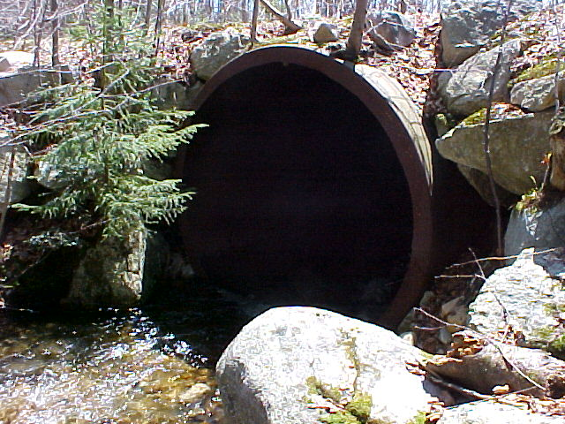
Typical road crossing over one of the many small perennial streams

Table 2: Summary of the Randolph Community Forest Road System

Road Name | Length (ft) | Culverts |  | Water Bars | Bridges | General Status
Pond of Safety | 19361.5 | 37 |  | 0 | 1 | good gravel road
Vernal Pool | 8655.8 | 2 |  | 16
Slate Ledge Brook | 768.9
Short | 710 |  |  | 3
Log Landing | 424.3 |  |  | 1
First | 7692 | 7 |  | 1
Hunters Pass | 4087 | 4
High Road | 7346 | 19 |  | 2 |  | 1 hollow log y.birch
Jim Town | 12129.2 | 25 |  | 14 | 1
Road Name | Length (ft) | Culverts |  | Water Bars | Bridges | General Status
Upper Valley | 3239.2 | 3 |  | 14
Walker | 13182.2 | 32 |  | 25
Lowe | 6462.8 | 8
Upper | 1511.6 | 5 |  | 2
Water Wheel | 9370 | 15 |  | 8 | 1
Basswood | 3834 | 6 |  | 2
Water Wheel Ext. | 1088.9 | see water wheel
Spoke | 1380 | 2 | 2
Softwood | 7235.6 | 2 | 12 |  | 1
Elderberry | 2393.3 |  | 6
Deerfly | 4907.8 | 7 | 2
Foundation | 1537.2 |  | 1
Jeep | 5019.8 | 2 | 10
Northsouth | 5700 | 17 | 8 |  | 2
Westeast | 3353 | 6 | 13 |  | 2
Lower reach | 1313 | 2 | 1
Wetlands | 2060
Nub | 150
Trout | 870
Little | 1206
Double Brook | 866
Pond Safety Access | 1168.6
Total | 141252.4 | 202 | 153 |  | 10
 | 26.8 Miles

Three of the main corridor roads are open to the public, subject to gates and bars in mud season or when the road surface is inundated and subject to rutting damage. The Pond Safety Road branches off the Ingerson Road in Jefferson and runs roughly east-west; the Jim Town Road branches off the Moose State Park entrance road in Gorham and also runs roughly west-east; the Walker Road branches off US Route 2 in Randolph and runs roughly north-south. There are numerous logging roads that branch off of the three main roads, most of which end at log landings, throughout the RCF.
Further descriptive and spatial location data for inventory and maintenance of culverts, water bars, and bridges will be stored in digital format as a coverage in the Randolph Community Forest geographic information system (GIS).

Draft of Language on USFS – DRED – Town Agreements
The Town has recently entered into two agreements which will have an effect on the management of the road system in the RCF. The first of these is a wide-ranging three-way memorandum of understanding (MOU) signed by the U.S. Forest Service (USFS), the state Department of Resources and Economic Development (DRED) and the Town. The MOU pledges cooperation among the parties in the management of the Community Forest. It recognizes that the Community Forest is a part of a larger tract of protected land which includes the adjacent portions of the White Mountain National Forest (WMNF) and that the management of the parts of the larger tract needs to be carried out in a coordinated fashion. The parties pledge to meet regularly, share information, cooperate in educational activities and provide technical assistance where appropriate.
The other agreement between the USFS and the Town relates specifically to the management of the roads. The Pond of Safety and the Hunters Pass Roads are defined as shared management responsibilities. Both pass through the RCF before entering the WMNF and it is in the interest of both parties to make sure that they are well maintained. Appendices to the Road Agreement identify the relative management responsibilities of the parties.
These agreements reflect the climate of cooperation which has characterized the management of the RCF to date. They will help to carry the pattern on into the future.

Multi-uses and Benefits
The extensive road system throughout the RCF serves many uses beyond timber removal to market. The public enjoys this access for recreational purposes that vary from wildlife observation to hunting and fishing, to picking wild berries, and even to view the scenery from some of the high spots. Access to numerous panoramic views via wheeled vehicles, or to hiking trails with relatively short hiking distances are scattered throughout the road system. Winter-use of these roads includes snowmobile travel connected to an extensive trail network. Cross-country skiers and snow shoers also utilize these roads in the winter. (Please refer to the Recreation section of this plan for further details.)
Associated with the multi-use aspect of the road system is the benefit of access for search and rescue teams, including areas for emergency helicopter landings should the need arise. Forest fire access to remote areas is yet another benefit of the RCF road system.
An often-overlooked benefit to these miles of mostly vegetated roadbeds is that wildlife extensively use them for travel corridors. The maintenance of brush hogging the road system and log landing areas creates miles of edge habitat and open spaces for diversity within this large forested area. (Please refer to the Wildlife section of this plan for further details.)

Inventory and Maintenance
All culverts, water bars, and bridges throughout the RCF road system have been spatially located using global position system (GPS) with accompanying photographs for each structure. Further, these data are being integrated into the Randolph Community Forest geographic information system (GIS) for ease of data retrieval, updating, maintenance scheduling, and plotting of maps. The RCF existing road system should provide access for all future logging without further expansion. In fact, there are some locations where roads may be closed to wheeled traffic and brush hogged on a three- year rotation benefiting wildlife and available for logging access in twenty years or more.
Over the past two years, the RFC has aggressively dealt with erosion problems and failed culverts, in some cases replacing under-sized culverts. Ditch maintenance and improvements have been also been addressed on an annual basis. Working with the US Forest Service, the Snowmobile Club, and others, the RFC has the opportunity to work within an annual budget to further improve drainage, prevent erosion, and address ‘trouble spots’ along these logging roads with the intent on achieving a point where only routine inspection and preventative maintain will be required.

There are many miles of roads throughout the RCF with good road base material and maintained drainage. (Many roads also have scenic views towards the Presidential Range in the WMNF.)

Road Materials
A tremendous advantage to the location of most of the road system is that of gravelly sandy soils which are prevalent in the RCF. Though these soils range from extremely cobbly and rocky to sandy, the majority of these roadbeds have favorable soils for the road base. There also are some locations throughout the RCF where gravel and sand moraines can be mined for road repair and maintenance. Fortunately, few materials have to be imported into the RCF saving purchasing and trucking costs.

6. Water Resources

The numerous small ponds, brooks, seeps, and drainage flows located throughout the RCF are a valuable resource and the ‘life blood’ of the entire ecosystem. Without this network of hydrology the RCF would lose most of its plant and animal species and its rich diversity. Water resources throughout the RCF are of high quality and often are referred to as ‘pristine’.

Rivers & Brooks
The drainage for the Randolph Community Forest consists of headwaters for three sub-watersheds; the Israel River which flows in a westerly direction towards Jefferson and Lancaster and the Connecticut River, the Moose River which flows in an easterly direction towards Gorham and its confluence with the Androscoggin River, and Moose Brook that also flows in an easterly direction towards Gorham with its confluence with the Androscoggin River. Refer to Map 1. A fourth headwaters area, the Upper-Ammonoosuc River watershed, which flows in a northerly direction towards Berlin, abuts the RCF along the northern easement boundary in the Pond of Safety drainage. Order 1 & 2 streams that flow from the RCF into these watersheds summarized in Table 3.

Table 3: Summary of Order One and Order Two Streams throughout the Randolph Community Forest.
Sub-Watershed | Order One and Two Streams | Distance within the RCF | Compartment(s)
Israel River: | Priscilla Brook | 2240’ | 1A
 | Little Ledge Brook | 8510’ | 1A, 1B
 | Big Ledge Brook | 12650’ | 2A, 1A
 | Stag Hollow Brook | 23127’ | 1B, 2B
 | Unnamed Brooks | 67395’
 | Sub Total | 113922’ Lineal
Moose River: | Carlton Brook | 5748’ | 4A
 | Unnamed Brooks | 93398’
 | Sub Total | 99146’ Lineal
Moose Brook | Moose Brook - tributary | 2600’ | 4B
 | Sub Total | 2600’ Lineal
 | GRAND TOTAL | 215668’ Lineal (41 mi.)
(Source of lineal drainage calculations is USGS Topographic Quadrants - digital raster graphics.)

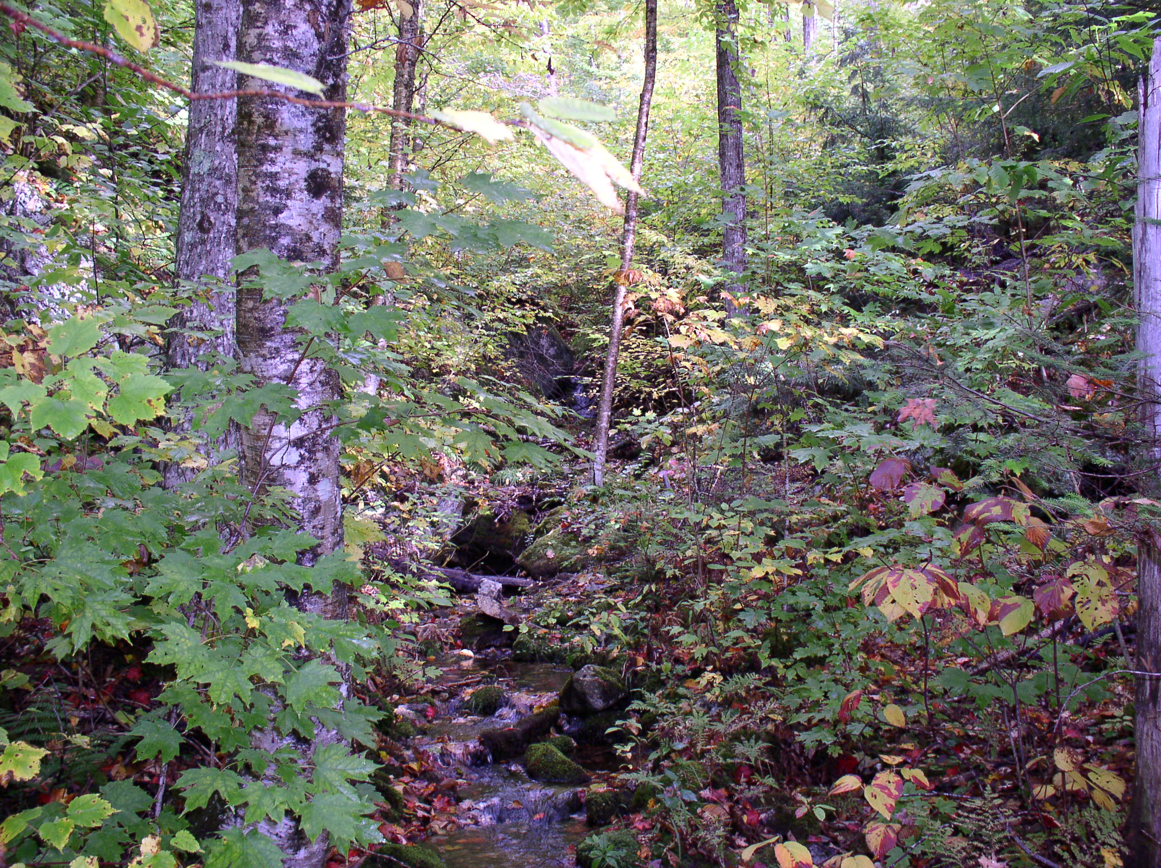
Typical cobbly bottom perennial stream with forested riparian buffer.

Water Quality
Throughout the RCF all streams and flows are considered high quality, often referred to as pristine. These waters meet Class ‘A’ standards under the New Hampshire classification system, signifying that they could be used for a drinking water source with treatment, support high water quality aquatic indicator species and are fishable and swim- able. These flowage headwaters have excellent vegetative buffers and riparian zones. There are numerous small reservoirs consisting of concrete and rock construction that were used as drinking water sources in the past with the largest one, the ‘Randolph Community Waterworks’ that used to be a public drinking water source for a portion of the Town of Randolph, still being used as a private source.
Water quality parameters including temperature, turbidity, pH, and specific conductivity are assumed to be within favorable ranges based on observed plant, fish, and wildlife throughout the RCF. With the typical geological granite-based bedrock, pH is expected to run within the typical range of 6-6.7 found in Northern New Hampshire with a few inclusion areas that contain slightly more calcareous bedrock material where soils and water may be ‘sweeter’ approaching a pH reading of 7. This is especially probable in the eastern-side of the RCF where geological mapping indicates potential calcium inclusions within the bedrock. (Please refer to the Action Plan section of this report for water quality sampling.)
The perennial streams contain local wild brook trout that successfully spawn and maintain a population throughout the RCF. Many were observed during inventory for this report. Properly installed bridges and large culverts for logging road crossings have provided aquatic connectivity to allow a homeostatic regime to continue for these wild trout and other aquatic species.
There are minor erosion and sedimentation incidents in a few atypical locations. These are attributed to past logging and road construction prior to ownership by the Town of Randolph and are correctable. (Please refer to future action plan section within this report.)

Wetlands
There are numerous wetland complexes within the RCF containing a diversity of plant and animal species and habitat of varying function values. These wetlands are the core of life for the majority of plant and animal species and offer diverse habitats with numerous ‘edges’ needed by many species. It is estimated that riparian areas and wetlands are utilized by over 90% of the region’s wildlife species and provide the preferred habitat for over 40% of these species. Future trails and/or observation points overlooking these wetlands provide excellent opportunity for wildlife viewing.
Based on aerial photography, topographic quadrants, soils maps, and preliminary fieldwork, there are approximately 98 acres of wetlands in numerous classifications within the RCF, varying from open water to emergent to palustrine forested. (There are undoubtedly additional acres of forested wetlands that require field delineation and have not been documented as of this report.) Vernal pools are a unique type of wetland that are found within the hydrological matrix of the RCF and are further discussed in the wildlife section.
An interesting occurrence throughout this property is that of the cyclic movement and associated open water creation by beavers. By utilizing aerial photography taken in the past, it is possible to track beaver population cycles over 10, 50 or even 100 years. Once the mature timber was harvested from various areas and regeneration of successional growth was in the 3-8 year old stage (mostly hardwood saplings) this abundant new food source attracted beaver. Beaver are unique animals in that they possess the ability to alter the environment around them by constructing dams and digging channels. Associated with this beaver activity, what was once upland forest with upland soils begins the slow evolutionary process to becoming wetland species and hydric soils. Based on aerial photography and fieldwork in the RCF there are many acres of ‘new’ wetlands due to beaver activities, present and past.
Typically, beaver will build one or two dams on a perennial stream plus a lodge. Dams and lodges are built out of mud (organic top soil layers and water) and saplings poles ranging from four to six feet in length. These poles are the residual of saplings cut down, sectioned, dragged into the water, and the bark removed as the beaver feed on the cambium inner bark layer. As the sapling supply is consumed immediately around the safety area provided by the pond water, beaver will excavate trenches further into the upland areas and/or will build the dam higher and longer. Restrictions to the size of the beaver ponds are generally due to slope abruptness and the proximity of reachable food/building materials. Eventually, usually three to five years, the beaver will move downstream or upstream and create new ponds and lodges, sometimes in a long series, perhaps miles long, seeking fresh young saplings. Another source of new ponds is the dispersal of the 2 to 3 year old offspring beaver from each colony as they are forced out of the ‘home’ area seeking new territory, often a considerable distance away.
This beaver/wetland creation cycle continues up and down these types of woodland streams over time when, eventually areas that were first dammed, on roughly a 20-30 year cycle, slowly return back to the original small streambed in size and characteristics. Typically, the sedimentation and pedoturbation (mixing of soils) of the former beaver pond and activities has supplied rich hydric organic soil for the successional growth of; emergent vegetation, to grasslands, to shrub-shrub saplings. There were times in the past, such as the decade of the 1960s, when man would intervene by trapping beaver out of a watershed such as this forest contains. Due to a lack of fur market value and public sentiment, this control of population is seldom utilized now. The beaver is a rodent, the largest in North America, and is prolific, as all rodents tend to be. With very little impact to natural predators and no trapping occurring, beaver are rapidly returning to former populations of the pre-Colonial period. Because of these modern trends, the saplings stage of succession in old beaver ponds does not continue the process to mature forest stands. The beaver generally re-inhabit the young sapling food source by re-building dams and lodges on or near the original sites.

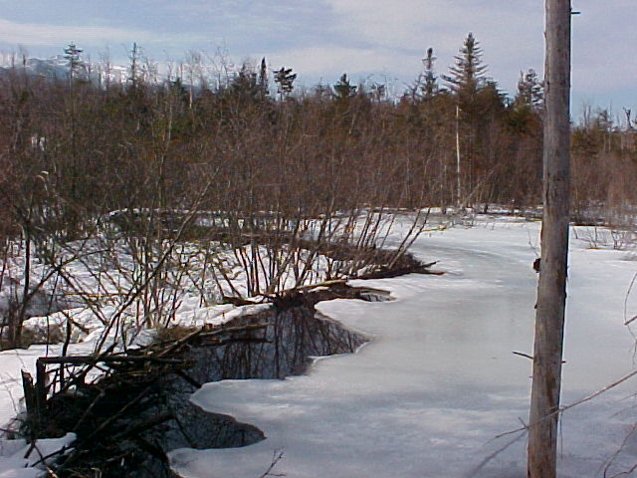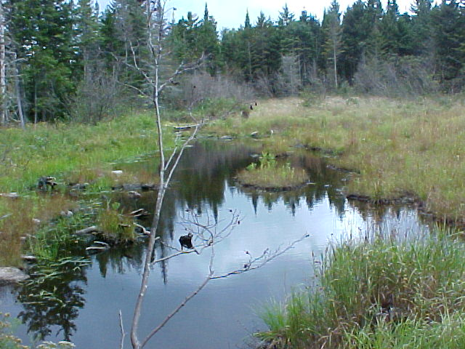
The left photo shows an active beaver pond found in the southeastern portion of the RCF. On the right is a wetland in the central area of the RCF where beaver have left the area. The wetland on the right has dried up dramatically due to the lack of beaver in this area.

The cyclic activities of beaver as their population increases have effected this property and many other properties throughout New England. The flooding of upland forest soils slowly kills off the mature trees not directly utilized by the beaver. Also, the inundated soils slowly revert from aerobic to anaerobic conditions with increased vegetation decomposition and sedimentation, forming hydric soils and expanded wetlands. Beaver activities flood small wooded areas that create natural high quality wetlands of diverse, rich habitat.

7. Wildlife Habitat

Over 60 species of land mammals, over 70 birds, nearly 20 reptiles, over 20 amphibians, and at least 16,000 insects inhabit the region, most of these occurring regularly (as opposed to passing through the area during migration). The diversity of wildlife species attracts residents and visitors for hunting, viewing, and educational purposes. During our inventories of wildlife and wildlife habitat throughout the Randolph Community Forest we found ample evidence of moose, bear, deer, coyote, fox, ruffed grouse, diverse song birds, raptors, frogs (wood, green, and leopard), spotted salamanders, and many different small mammals. The diversity of habitat along with a large undeveloped space allows for these species to thrive.

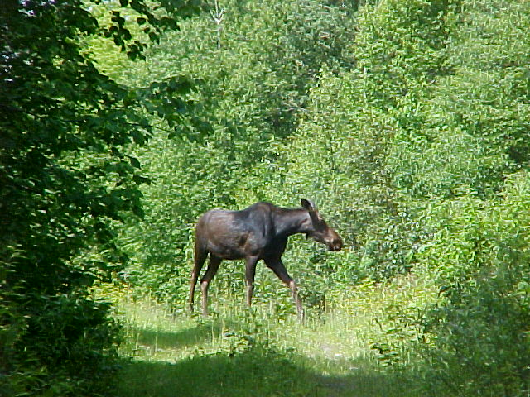
The RCF has a healthy moose population based on sign and sightings. The Forest contains excellent moose habitat.

During fieldwork throughout the RCF, the following characteristics were noted and examined to assess the value of wildlife habitat:

- Structure – shape, height, leaf density throughout all levels of forest canopy: grass, herb, shrub and tree vertical layers
- Patchiness – a mosaic effect throughout the Forest that gives, for example, wildlife a sunny patch of berries right in the middle of a dense softwood stand.
- Edge – The junction between two different communities is one of the most diverse and intensely utilized places in a forest. On these edges, wildlife from each community can be found together, along with those edge-preferred species.
- Size – Certain species of wildlife need large areas of unbroken terrain. For example, oven birds often build their nests deep in these extensive forests. In addition large mammals, such as bears, bull moose, and lynx need a large home range to support themselves.
- Special Features – these include open water, cavity trees, cliff outcrops, and higher elevations.

In many areas of the RCF all five characteristics were found, some in abundance. For example, the large acreage of the Forest along with its connectivity to the White Mountain National Forest to the north and south, could support many different wildlife species requiring large territories. In addition, many different wildlife species were noted in edge habitat along roads, log landings and openings. Furthermore, during song bird breeding, several species of warblers, sparrows, wrens, and thrush, were noted at different levels in the canopy throughout the Forest.
Habitats of special interest to the Forest include open space, dense softwood stands, regenerating aspen stands, open water wetlands, vernal pools, and mast producing trees. There are nearly 90 acres of open habitat, 335 acres of dense softwood stands, over 40 acres of open water wetlands throughout the RCF. A summary of these is listed in Table 4 below.

Table 4: Summary of unique habitat types throughout the Randolph Community Forest
Habitat Type | Number of Acres | Number of Square Miles | Percentage of RCF Land Mass
Randolph Community Forest Boundary | 10,216 | 16 | 100%
Dense Softwood Cover | 335 | 0.5 | 3.2%
Open Water Wetland Complexes (from DOQ digitization) | 40.5 | 0.06 | 0.4%
Permanent Openings | 89.9 | 0.14 | 0.9%
2500+ Elevations | 2,038 | 3.2 | 19.9%

Permanent Openings
Permanent openings, dominated by grasses, forbs, brambles, or fruiting shrubs, provide necessary habitat for about 22% of New England’s wildlife species, and seasonally important habitat to nearly 70% of species. The eastern bluebird and eastern cottontail are two examples of species of concern in New Hampshire, which rely on retaining permanent open areas. Permanent openings in general also have the advantage of creating edge habitat. Wherever an open area meets the forest the area of transition will attract the largest diversity of species, both plant and animal. Generally, there will be species adapted to permanent openings, those adapted to forested habitat, and those that specialize in the transition zone area and frequent these edge habitats.
Of the 89.9 acres of open habitat found throughout the RCF, two places stood out as unique and important wildlife openings in the forest. The first involved a grassland containing approximately 6 acres. This unique grassland was found along the farthest portions of Softwood Road (Compartment 2B, Stand 5-32 border). Refer to Map 2. During a site visit on July 14, 2003, several deer and moose bedding sites were found. Despite the field work being at the end of song bird breeding, several bird species were heard including flickers, phoebes, chickadees, robins, and winter wrens. The transitional elderberry and brambles along with mature hardwood stands adjacent to the grassy opening provide soft and hard mast as an additional attractant to a variety of wildlife species. A second opening of special interest was along the Pond of Safety Road (Compartment 2B, Stand 10), which contains approximately 11.3 acres of opening. The uniqueness of this site is especially of interest because it is adjacent to a stand of dense softwood and also the Stag Hollow Brook. The diversity of open, transition, softwood, riparian zone, and running water will continue to attract a number of wildlife species.

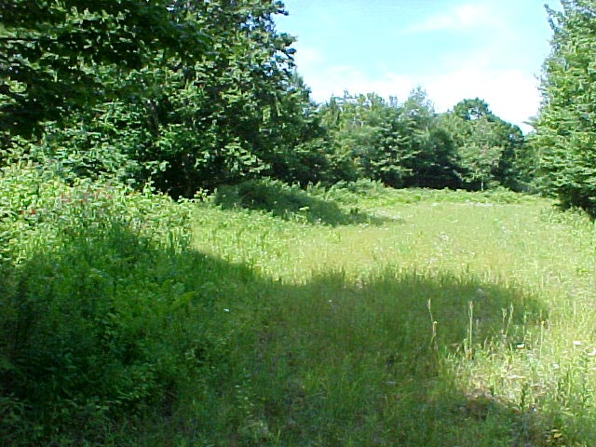
Unique grassland habitat along Softwood Rd. in the RCF. Several deer and moose bedding sites were found. This is a unique site on the Forest.

Dense Softwood
Dense softwood stands are other areas of importance throughout the RCF. They provide shelter to animals from harsh winter weather by reducing snow accumulation and wind speeds, while allowing access to food supplies and escape from predators. Historically there were large tracts of softwood stands and deer wintering areas (also called deer yards). Today, however, many of the dense softwood stands scattered throughout the Randolph Community Forest are quite small in size (1 to 15 acres). There are a few larger softwood areas ranging from 30 to 60 acres in size. Many of the softwood stands are associated with watercourses and riparian habitat as shown on Map 2. Moreover, some of the larger softwood stands are found above the 2500-foot elevation mark. During site visits throughout the spring, summer and fall of 2003, evidence of deer and moose were found in many of the softwood stands. Historically, there were larger softwood stands used as wintering areas for deer. Previous logging activities have transitioned these softwood stands into hardwood stands of varying age classes. Even though deer may not use some of the smaller softwood stands in the winter, many other smaller mammals and birds rely on them.

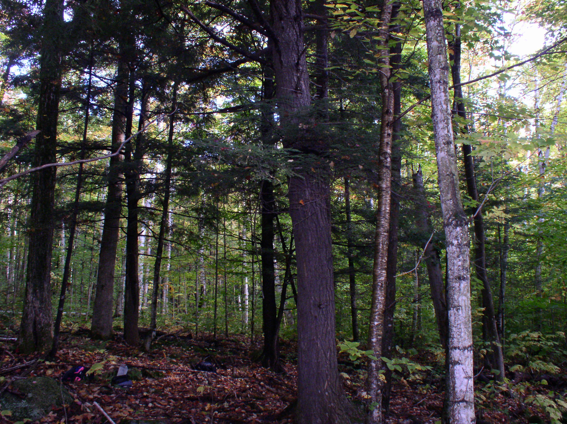
A small softwood stand found throughout a mature hardwood stand. During field work signs of bear, deer, moose, wood peckers, and snow shoe hare were found in this stand.

Aspen Stands
Aspen stands are the preferred habitat for several wildlife species including ruffed grouse, woodcock, and beaver. Aspen are an early successional species. This means that they are one of the first trees to grow after an area has been cleared by fire or logged to expose the soil and allow direct sunlight to penetrate to the forest floor. During field studies of the RCF abundant Aspen stands were found, since the area was heavily logged in the past. There was abundant ruffed grouse sign throughout the year in part due to the aspen stands. Because aspen die off as the forest matures, natural disturbances or small clear cuts are necessary to propagate the species.

Mast Trees
Mast refers to nuts, seeds, and fruits of woody plants that provide food for wildlife. “Hard mast” refers to nuts and seeds; “soft mast” refers to fruits and berries. High levels of fat and protein in mast contribute to fat stores critical for migration or hibernation. In the RCF the predominant hard mast species is American beech. Soft mast species are more diverse and include black cherry, pin cherry, choke cherry, mountain ash, shadbush, brambles (black berries and raspberries), and high bush cranberry. During field inventories of the RCF several species of hard and soft mast were found scattered throughout the entire forest. Based on the diversity of wildlife, and ample mast producers, there does not appear to be any shortage at this point.

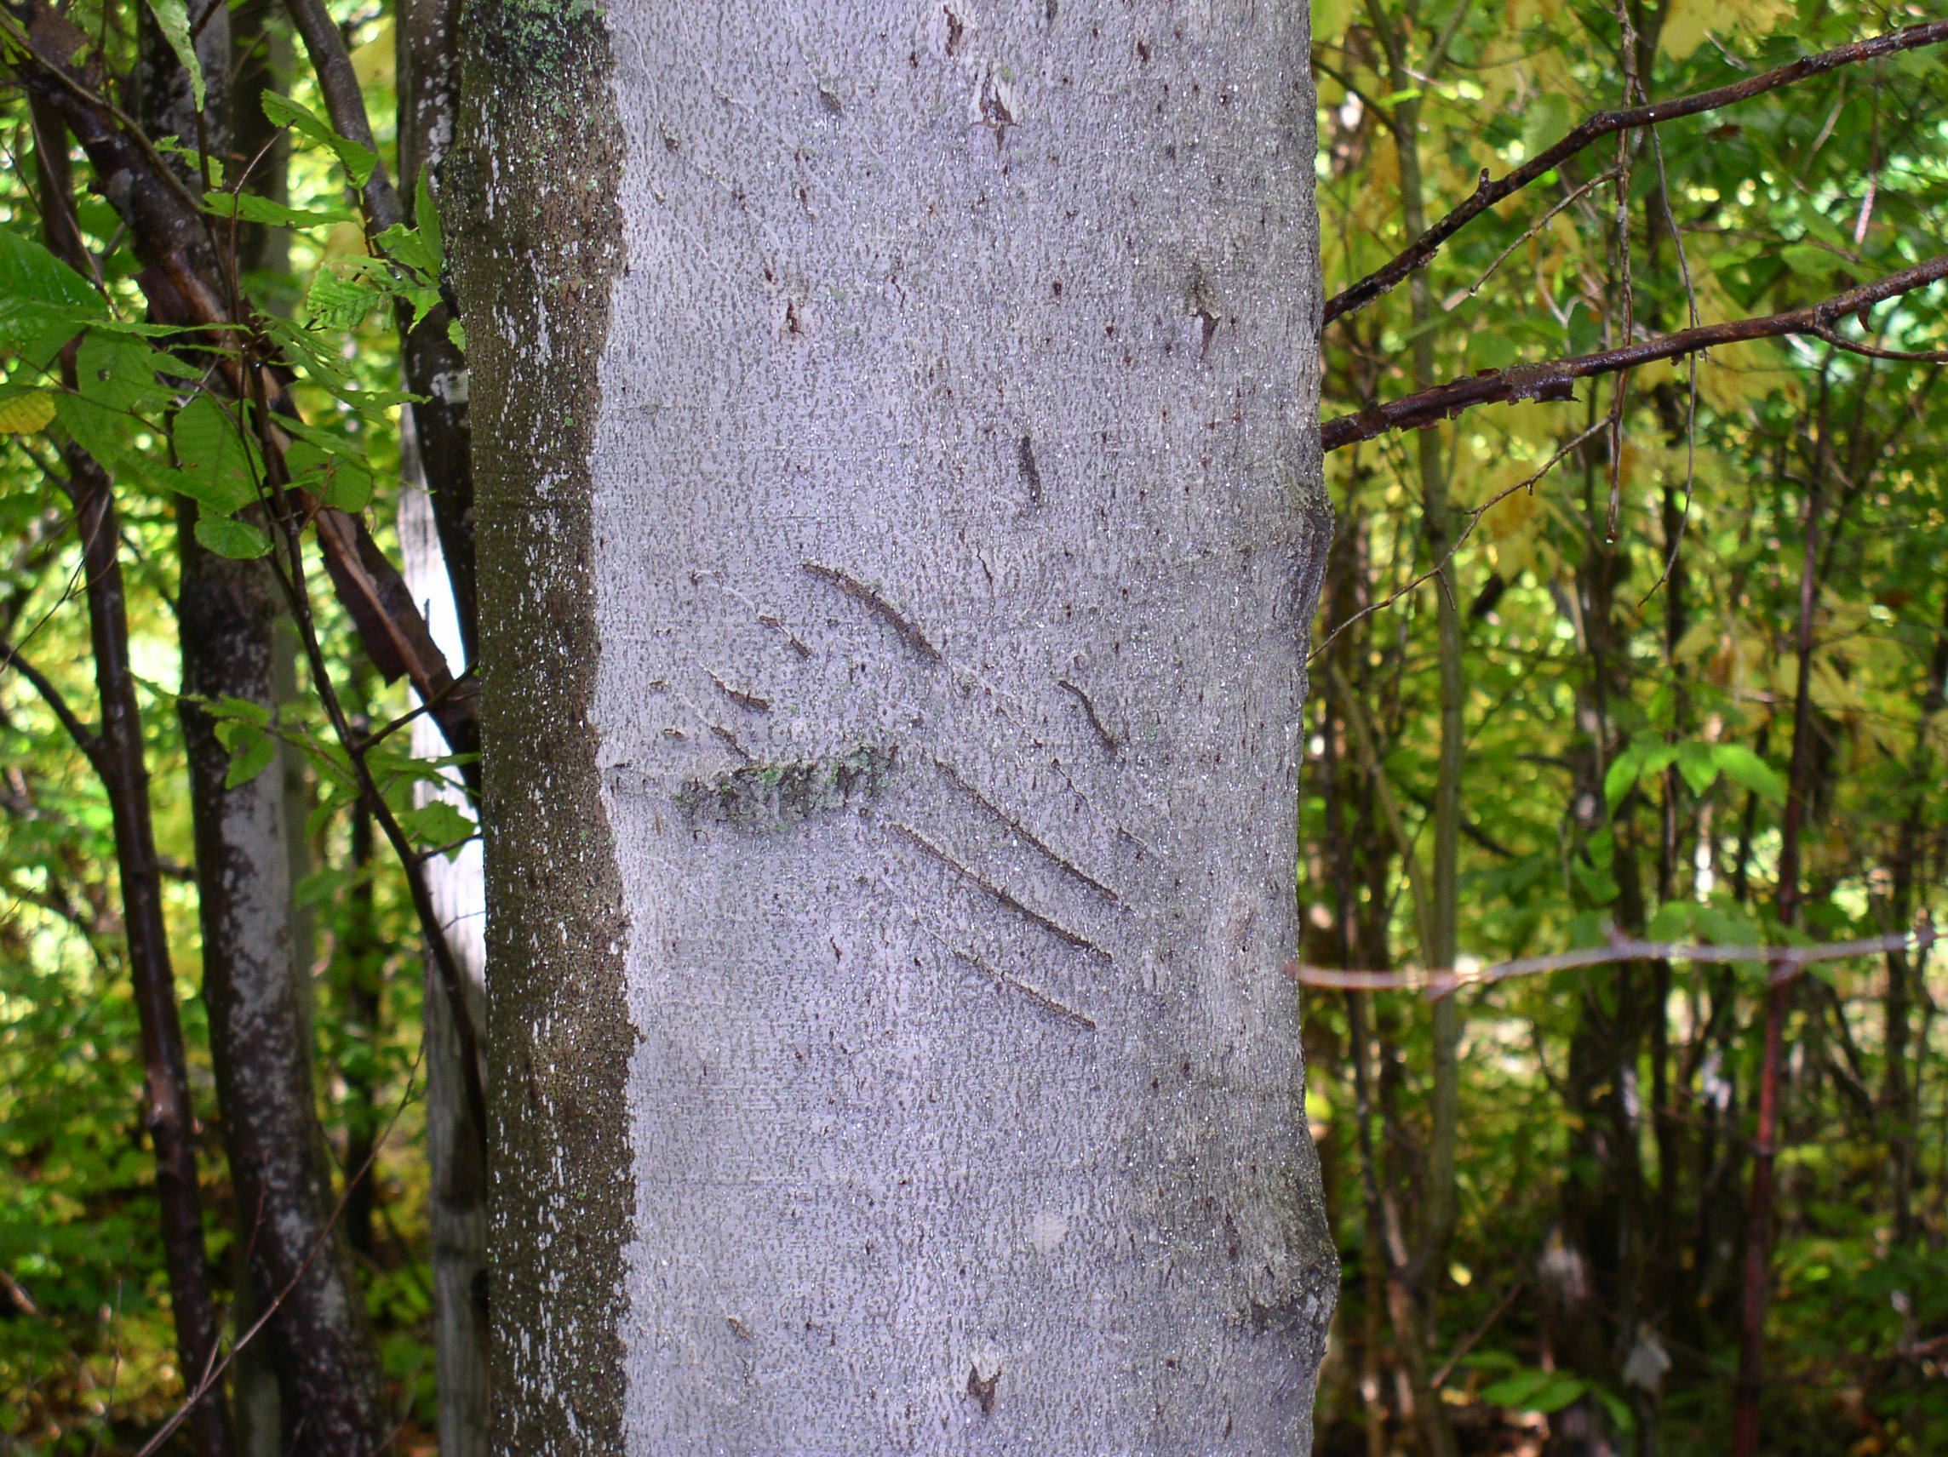
The bear claw marks on this American Beech indicate that it is a good mast tree in the RCF. During site visits, several of these trees were found scattered throughout the Forest.

Vernal Pools
Vernal pools are a distinctive and unique type of wetland which merit a discussion of their own. A vernal pool is described as a temporary body of water which provides essential breeding habitat for certain amphibians and invertebrates. These unique wetlands typically cycle annually from flooded to dry. Vernal pools vary in size, shape and location, and are valuable wildlife habitat because of the wide range of species that use them including, turtles, frogs, salamanders, fairy shrimp, clam shrimp, fingernail clams, caddis flies, dragon fly larva, and other aquatic insects. Vernal pools provide a safer breeding ground for these species than permanent waters, because there are no fish to eat the eggs or larvae. Vernal pools also act as watering holes for many wildlife species.

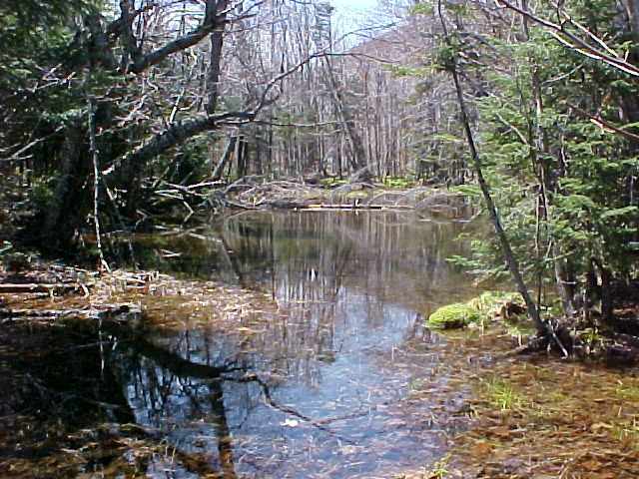
Vernal pool Number 2 found in the RCF. Several vernal pool amphibians and insects were found.

During fieldwork 7 vernal pools were found and documented in the Forest, and are described in the table below. Undoubtedly, there are many more pools throughout the RCF, and they will be continually documented and updated as they are discovered. Four of the vernal pools (Nos. 1, 3, 4, 5, 7) were found along the road or in an old gravel pit, and were probably formed through the construction of the road and/or removal of gravel from the area. Vernal pool number 2 is more typical of a woodland vernal pool with good canopy closure all around. It is interesting to compare the two vernal pools on Vernal Pool Road: number 1 being near a gravel pit and on the side of the road; and number 2 being in a wooded area off any roads or trails. Both vernal pools had a good diversity of amphibian and aquatic insect life, but the smaller, roadside vernal pool had a higher density of species.

Table 5: Summary of Vernal Pools Found During 2003 Field Season

Vernal Pool Number | Location  (GPS coordinates) | Size (feet) | Species Discovered  (* = NH obligate vernal pool species) | Road Name
1 | None taken – at gravel pit on Vernal Pool Road | 50 x 25 | *wood frog  *spotted salamander  green frog  caddis fly larvae | Vernal Pool Rd.
2 | N 44° 24.638’  W 071° 22.890’ | 300 x 70 | *wood frog  *spotted salamander  American toad  caddis fly larvae | Vernal Pool Rd.
3 | N 44.41915°  W 071.37936° | 5 x 5 | *wood frog  green frog | Jeep Rd.
4 | N 44° 24.035’  W 071° 20.791’ | 50 x 20 | *wood frog  *spotted salamander | Pond Safety Rd.
5 | N 44° 23.523’  W 071° 22.187 | 30 x 25 | *wood frog  green frog | Softwood Rd.
6 | N 44.41075°  W 071.37634° | 25 x 15 | *wood frog  *spotted salamander  green frog  caddis fly larvae | Jeep Rd.
7 | None taken | 20 x 6 | *wood frog | Water Wheel Rd.

High Elevation Regions
Over 2,000 acres or nearly 20% of the RCF contains land above 2,500 feet in elevation. Studies have shown that the land above 2,500 feet in elevation throughout northern New Hampshire contains a unique and fragile habitat. The harsh conditions at the alpine and subalpine zones have created a number of more narrowly defined plant communities. These communities tend to arrange themselves along gradients of elevations, moisture (both soil and atmospheric), exposure, slope and snow cover. Visits to these higher elevation areas demonstrated a lower diversity of plant species compared to the lower elevation areas. There was also evidence of past timber harvesting activities, primarily old skid roads. The main plant community found at the higher elevations is the Subalpine spruce-fir community. Boreal outcrops (subalpine) were also found. The primary threat to the plant species in these areas (particularly in the alpine zones) is trampling by hikers. Potentially, however, much greater threats to the plant communities are increased nitrogen deposition and global climate change. The Conservation Easement prohibits timber harvesting above the 2,500-foot mark. This will help protect the fragile environment.

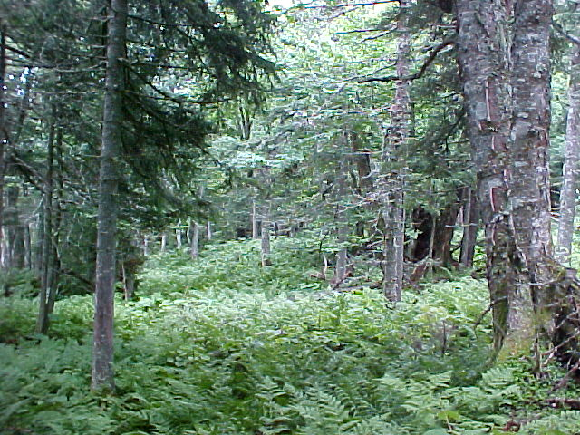
Areas above 2500 feet in elevation are unique and fragile areas in the RCF.

Summary of Wildlife Habitat
To summarize wildlife habitat, the size of the RCF and its proximity to large contiguous open space, offer distinct and unique opportunities for wildlife monitoring, conservation, and wildlife habitat management. There are opportunities to continue to work towards connecting the RCF to the White Mountain National Forest south of U.S. Highway #2.
Today, one of the greatest threats to wildlife species is the loss of habitat. The Randolph Community Forest and adjacent White Mountain National Forest and Gorham Town Forest have abundant wildlife habitat at this time. This gives people an opportunity to retain what they do have for diversity throughout the region rather than having to attempt to “fix” an area which has been fragmented by development and associated habitat loss.

8. Rare Species and Exemplary Natural Communities

The Randolph Community Forest has the potential to accommodate a wide variety of rare species and exemplary natural communities because of the diverse habitats which exist within its bounds. One particularly promising area is in the northwest portion of the forest (compartment 1A) which is characterized by calcareous soils, not very common in this region or throughout New Hampshire. Rare species are often found on such soils.
During field work assessments, no rare species were documented. However, further fieldwork is planned in future projects, and this will be outlined in the Action Plan section. Appendix B contains a list of rare, threatened, or endangered species and exemplary natural communities found in the Towns of Randolph and Jefferson. Most of these species have historical occurrences, which mean that they have not been seen for over 20 years. Data here came from the New Hampshire Natural Heritage Inventory Bureau (NHI). NHI locates, monitors, and provides information on these rare species and exemplary natural communities.
Presently, there are four documented rare species found within the boundary of the RCF. These include one insect (a notcuid moth) and three plant species. All are found above the 2500-foot elevation and have not been documented since the early 1900s. However, there are several other rare species and exemplary natural communities found outside of the RFC boundaries in the adjacent WMNF and the Town of Jefferson. Because all of the NHI data within the RCF boundaries are historical, there is no database with exact locations. Current and future work throughout the Forest, however, could identify and document these species and/or communities for future monitoring and research.
New Hampshire is home to more than 500 species of vertebrate animals. Many of these animals live in the Randolph Community Forest and the surrounding areas. The total number of species would be considerably larger if a complete list of invertebrates (insects, crustaceans, clams and snails) were included. About 75 percent are nongame (not hunted, fished or trapped) wildlife species. Twenty-one species are endangered and thirteen are threatened in the state. The New Hampshire Fish and Game Department maintains a list of Endangered or Threatened animal species in New Hampshire, which is shown in Appendix B. Little information is available relative to their occurrence in the RCF, but their habitats, when identified, should be protected.

9. Visual Resources

The Randolph Town Forest is in a visually sensitive area. It is within the viewshed of U. S. Highway #2 as a foreground, middle-ground and background view. Most of the forest can be seen from the Presidential Range above tree line where thousands of hikers have a superior, middle-ground to back-ground view of it. Stag Hollow Road, Randolph Hill Road, the State snowmobile trail system, and several hiking trails provide a fore-ground view. The public is very concerned about the appearance of this landscape. They know it as forest land and that is what they expect to see when they view it.

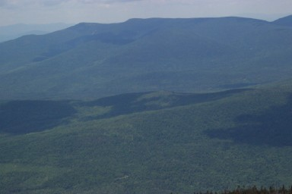
View of the Randolph Community Forest from Nowell Ridge to the south. There are scenic views both towards and from the RCF.

Presently, what people view is a naturally appearing landscape when observed as a background view, especially in the summer when there is less contrast between age classes of stands. Most of the past cutting activity on the forest maintained a high canopy appearance. Some of the harvesting associated with the ice storm is noticeable but it is subordinate to the overall landscape. An exception to this is a spot called “the scar” which is a skid road at the base of Mt. Crescent.
Timber harvesting activities are seen and are very noticeable when seen from the roads, snowmobile trails, and hiking trails that are within the forest. Also observed are some of the ice storm damaged, broken trees. Another exception to the naturally appearing landscape is harvesting that has recently taken place on private land abutting the forest. These rectangular cuts catch the eye first.
Future timber sales will take into account the sensitive viewshed in which they are taking place. Timber harvesting activities may be noticeable, but they will be subordinate to the surrounding landscape by keeping group cuts, patch cuts and clear cuts proportionally small in size, flowing with the landscape, and natural in appearance. During timber sale planning, cuts will be simulated on computer terrain models to assess their appearance. No harvesting will take place during April through June to avoid rutting and removing the bark from trees. Thinnings or partial cuts will be done during August-September and winter months to avoid removing bark from trees. Other practices listed in the Aesthetics Section of Good Forestry in the Granite State will be followed to protect the visual resource.

10. Recreation

The RCF offers diverse recreational opportunities throughout the Forest in all four seasons of the year. With topography that runs the spectrum from nearly flat to extremely steep, a variety of recreational uses are enjoyed. Many local residents as well as a large number of tourists are attracted to areas of the RCF for their respective interests and uniqueness. Though the Forest as a whole, being the largest Town owned forest in New Hampshire, is in itself an attraction, there are road, trail, and natural resource areas that are of particular interest. Further description of RCF uses follows:

Hiking Trail System
The RCF contains many miles of hiking trails that vary in length and degree of difficulty from very easy accessible scenic vistas to rather steep long Montaine Forest (2500’ elevation and above) wilderness areas. The hiking trails in the RCF are maintained by the Randolph Mountain Club (RMC). Some popular hiking destinations within the RCF or adjacent to it are Mount Crescent, Mount Randolph, Lookout Ledge, Carlton Notch, and numerous scenic vistas. Other nearby hiking trails access attractions near the RCF trail system such as Ice Gulch, Pond of Safety, the Presidential Mountain Range, Kelton Crag, Boy Mountain, and Pliny Mountain, to name a few.

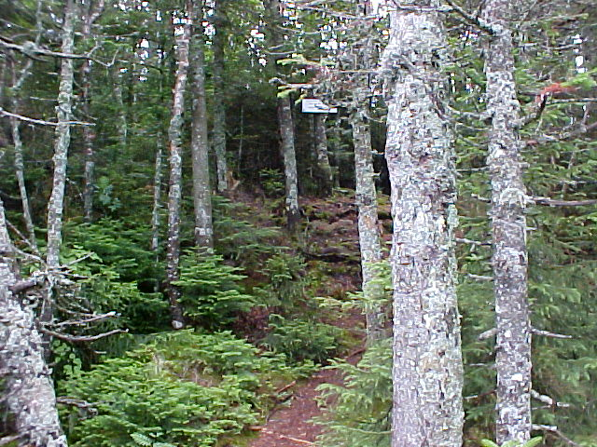
Mt. Crescent hiking trail. There is a large network of trails throughout the RCF maintained by the Randolph Mountain Club.

Snowmobile Trail System
There are over 15 miles of snowmobile trails throughout the RCF, most of which are along existing logging roads. These trails are maintained and groomed by the Waumbeck Methna and White Mountain Ridge Runner Snowmobile Clubs, and are a link to the extensive network of New Hampshire snowmobile trails that offer access to other states and Canada. The RCF Commission and Jefferson Club have good working relationships and common goals that benefit the local area and the large tourist clientele. It is difficult to estimate the number of people that use the snowmobile trails in the RCF, but it is believed that the number is high.
One significant use of the RCF snowmobile trail system is cross-country skiing. Due to the width of these groomed trails, both traditional classic and skating style skiing are possible. Access to other portions of the RCF road system that are not groomed nor part of the main corridor of snowmobile trails provide opportunities for backcountry and telemark (glade) skiing.
There is limited unauthorized ATV use of the snowmobile trail and road system throughout the RCF. At this time light ATV activity has caused very little impact to the RCF. Due to the nature of the topography, hardpan soils, and hydrology of the RCF, increased ATV use may have to be further evaluated in the future.
Snowshoeing opportunities are excellent off the snowmobile trail system throughout the RCF and allows for wildlife viewing, tracking, and scenic vistas. Due to the aforementioned topography and size of the RCF, it is possible to traverse a wide variety of terrains and habitat types not impacted by other winter recreational uses.

Hunting and Fishing
The Randolph Community Forest is home to numerous species of birds, mammals, and fish that offer sporting recreational activities. The matrix of habitat within the RCF provides sustainable populations of these species. Public access with an extensive road system allows hunters and anglers of all ages and fitness levels to enjoy their respective sports within the RCF.
Moose, white-tailed deer and black bear are large game species hunted in New Hampshire on an annual basis. Ruffed grouse, woodcock, and snowshoe hare are prevalent throughout most of the RCF and offer small game hunting opportunities. There are also limited opportunities for hunting black duck, teal, wood duck and other waterfowl in the numerous open water wetland complexes, dynamically revolving around beaver activities. Other species that are hunted in New Hampshire and found within the RCF include coyote, fox (red and gray), fisher, and skunks. Bobcat are now a protected species in NH but were once hunted in the RCF.
The numerous drainage brooks, rivers, and beaver ponds combined with cool, well shaded riparian wooded buffers allow wild brook trout to maintain a sustainable population in many areas of the RCF. Anglers are offered the choice of close by fishing or relatively inaccessible fishing sites.
Trapping for fur-bearing animals was once a common occurrence in New England and within the RCF area. Though this sport continues, it is not as popular as in the past due to public opinion and a weak global fur market. Common fur-bearing species found in the Randolph Community Forest are beaver, mink, muskrat, weasel, skunk, fox (red and gray), coyote, fisher, raccoon, and river otter. Most of these species have trapping seasons and laws established and regulated by NH Fish and Game. Currently, The RFC issues one annual trapping permit within the forest. Protected fur-bearing species that may exist in the RCF, now or in the future, are pine marten, bobcat, and lynx.

Other Recreational Uses
The RCF offers a wide range of more diverse activities such as photography, geology, botany, landscape painting, Lepidoptera (moth and butterfly) collecting, hobby rock collecting, horseback riding, jogging, and mountain biking on established roads.

11. Forest Protection

Fire
The risk and hazard of fire is rated as low. Fortunately, the forest receives an even amount of precipitation year-round keeping fuel moisture levels high. There are some exceptions to this during drought periods but due to the surrounding mountains some precipitation is squeezed out of the clouds. The hardpan soils that underlie much of the forest keeps moisture near the surface of the ground. The public is careful about fire. Lightning-caused fires rarely happen. The ice storm temporarily increased fire hazard, however, by increasing fuel loading in some areas. This is gradually being reduced as these fuels rot.

Insect and disease
There are four insects and two diseases that cause losses to hardwood tree volume and quality. Two of the more significant ones are the beech scale, Cryptococcus fagi punctures the bark allowing a bark killing fungus, Nectria coccinea var. faginata, to enter. This disease results in both volume loss and tree mortality in beech. Saddled prominent and Bruce’s span worm are two defoliators of sugar maple trees. Outbreaks of these two are neither too frequent nor extensive but they do result in volume loss when they occur. Larval galleries of the sugar maple borer result in partial girdles and decay and increase susceptibility to wind breakage. Eutypella canker found in maples results in stem quality defects and wind breakage. Two other diseases causing losses in hardwood volume are hypoxylon canker that infects aspen and black knot that infects black cherry. Red heart in balsam fir and red ring rot in spruce are two diseases causing losses in softwood species. To date, however, the hemlock woolly adelgid has not been seen in the RCF.

Wind
Wind causes the most stand volume loss of all the damaging agents. It breaks or fells weakened trees and downburst knock down healthy trees. Spruce and fir stands are especially vulnerable to wind storm damage because they are shallow rooted on hardpan soils. Hardwood species growing on these sites are also affected. Prevention measures against wind throw are to maintain tree health and to closely evaluate sites prone to wind damage and leave wind breaks at the edges of stands to reduce the speed of wind entering the stand.

12. Timber

Previously, the Randolph Community Forest was an intensively managed industrial forest. Harvesting activity within the forest intensified approximately 65-70 years ago and continued throughout the area until 2000. The first harvests were mature, better quality trees and the salvage of timber damaged by the 1938 hurricane. These were more or less “logger’s choice” harvests. For the past 35 years the designation of areas and trees for harvesting has been prescribed by foresters resulting in the generation and growth of higher quality trees and stands.
In 1998 a devastating ice storm affected this region. The middle, east side and higher elevations of the forest were especially hard hit. Refer to Map 3. Hancock Timber Resource Group (HTRG), that was the owner at the time, salvaged most of the damaged stands and trees resulting in approximately 10% of the forest being in the regeneration age class, 0-10 years old. Between this and other previous stand entries made by James River Company foresters almost all stands within the forest have been treated during the past 20 years. The exceptions to this are 4 stands that have not been recently cut due to limited access or because they were formerly owned by the Gorham Land Company. HTRG did not harvest all of the heavily damaged trees before they ceased operations. Some stands classified as “poor quality” remain. They will be discussed further in the compartment description of the timber resource.
Since most stands have been “thinned” within the past 25 years, the average stand basal area is 67 square feet per acre. Stands should grow well at this level and most of the growth will occur on sawtimber sized trees increasing their value as they improve in quality. The predominant species in all compartments is sugar maple, a valuable species.

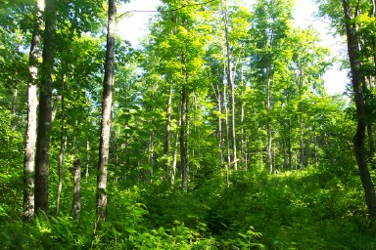
Typical timber stand found throughout the Randolph Community Forest.

Compartment 1A Timber Narrative
Compartments 1A&B are located on the west side of the forest in Jefferson. Refer to Map 4. During the past 17 years almost all stands were harvested with either a thinning or uneven-age selection cut. Table 6 below illustrates the unbalanced distribution of stands, especially the seedlings, saplings and poles. Sugar maple is the predominant species in most stands. Past thinnings probably discriminated against other species to develop sugar maple crop trees.

Sustainability
The distribution of size classes within the compartment is not balanced, meaning that some size classes are under-represented or over-represented. This condition does not allow for sustainable timber harvesting. The distribution of area in the various size classes across the entire compartment is detailed in table 6:

Table 6: Summary of size class distribution throughout Compartment 1A

Size Class | Balanced Range | Actual Percent Area | Difference
Seedlings | 5 -10 | 0.8 | -4.2
Saplings + Poles | 35 – 45 | 9.1 | -25.9
Small Sawtimber | 25 – 35 | 90.1 | 55.1
Large Sawtimber* | 10 -15 | 0.0 | -10.0
*Trees > 23”

In order to improve the distribution of size classes in this compartment, a total of 50 acres of patch cuts, 3-5 acres in size, are recommended for stands 3, 10 and 12.

Stocking
Stocking is a measure of how well the growing space available for trees is being occupied. It is most useful when determined on a stand-by-stand basis. There are several different measures that estimate how 'crowded' a forest stand is, generally based on how many trees there are and what size and species they are. This report addresses basal area and relative density as measures of stocking.
This compartment contains stands that range in basal area from 38.0 to 86.7 sq ft/ac with an area-weighted average basal area of 67.1 sq ft/ac. This stocking is too low to support another thinning now. Generally the basal area of a stand should be 100+ to recommend it. This basal area range is desirable for the continued growth of potential crop trees, quality sugar maple and white ash. The various species present in the compartment are listed in Table 7 below by rank order of overall basal area.

Table 7: Total basal area of species in compartment 1A

Species | Basal area | Percent
Sugar maple | 28,486.8 | 58.9
White ash | 4,511.2 | 9.3
American beech | 3,368.8 | 7.0
Yellow birch | 6,143.0 | 12.7
Paper birch | 1,059.1 | 2.2
Red maple | 1,658.1 | 3.4
Quaking aspen | 1,198.5 | 2.5
Balsam fir | 910.0 | 1.9
Black cherry | 341.5 | 0.7
Red spruce | 412.7 | 0.9
Black ash | 292.0 | 0.6
Total | 48,381.6 | 100.0

Relative density is a measure of tree crowding that accounts both for the size of each tree and the amount of space typically occupied by a tree of that species, so it is an especially useful measure in mixed species stands. A relative density of 100 percent implies that the growing space is fully occupied and trees must either slow their growth to survive, or some trees will be crowded out and die, making room for more vigorous ones. This compartment contains stands that range in relative density from 29.3 to 66.8 percent with an area-weighted average of 51.6.

Timber volume
Timber volume is a good estimate of the productivity of forested sites. These figures refer to net volume which is calculated or estimated by deducting from gross volume the loss of sound wood to insects, diseases, or other damage. Timber volume on the entire compartment totals 2.002 million board feet of sawtimber plus 435,141.4 cubic feet (5,508 cds.) of pulpwood, for a total volume of 689,452.7 cubic feet. The board foot volume of stands within the compartment ranges from 582 to 6,025 bd. ft/ac with a weighted (by area) average of 2,777 bd.ft/ac. Cubic volume of the stands ranges from 271.4 to 881.0 cu.ft/ac, averaging 603.5 cu.ft/ac. Volumes by species across the entire compartment are presented in Table 8. More details can be obtained from the tabular reports.

Table 8: Timber volumes of species from compartment 1A

Species | Net bdft | Percent vol. | Net pulp vol. | Percent
Sugar maple | 1,312,744.0 | 65.6 | 255,381.9 | 58.7
White ash | 226,225.1 | 11.3 | 43,665.5 | 10.0
American beech | 83,477.9 | 4.2 | 30,890.4 | 7.1
Yellow birch | 240,352.9 | 12.0 | 49,794.1 | 11.4
Paper birch | 17,826.9 | 0.9 | 12,392.1 | 2.8
Red maple | 14,980.8 | 0.7 | 18,683.3 | 4.3
Quaking aspen | 35,744.8 | 1.8 | 9,439.7 | 2.2
Balsam fir | 32,730.9 | 1.6 | 5,644.2 | 1.3
Black cherry | 7,399.4 | 0.4 | 3,426.5 | 0.8
Red spruce | 31,071.0 | 1.6 | 2,704.9 | 0.6
Black ash | 0.0 | 0.0 | 3,118.8 | 0.7
Total | 2,002,553.6 | 100.0 | 435,141.4 | 100.0

Compartment 1B Timber Narrative
Harvesting activities took place in all stands in 1997-98. This is the explanation for the information that follows. The larger trees have been removed from stands and the residual basal area has been reduced to a level that will allow the regeneration and growth of new seedlings and good growth rates on residual trees. Even though the age classes in the stand are not balanced at this time, no prescriptions to create more regeneration are being made.

Sustainability
The distribution of area in the various size classes across the entire compartment is detailed in Table 9.

Table 9: Summary of size class distribution throughout Compartment 1B

Size Class | Balanced Range | Actual Percent Area | Difference
Seedlings | 5 -10 | 0.6 | -4.4
Saplings + Poles | 35 – 45 | 34.3 | -0.7
Small Sawtimber | 25 – 35 | 65.1 | 30.1
Large Sawtimber* | 10 -15 | 0.0 | -10.0
*Trees > 23”

Stocking
This compartment contains stands that range in basal area from 23.3 to 74.0 sq ft/ac with an area-weighted average basal area of 50.9 sq ft/ac. The various species present on the compartment are listed in Table 10 below by rank order of overall basal area.

Table 10: Total basal area of species in compartment 1B
Species | Basal area | Percent
Sugar maple | 3,708.5 | 43.4
Yellow birch | 2,378.5 | 27.8
Red maple | 1,148.5 | 13.4
Black ash | 274.0 | 3.2
Red spruce | 312.0 | 3.6
White ash | 192.0 | 2.2
Quaking aspen | 191.0 | 2.2
Black cherry | 138.5 | 1.6
Balsam fir | 80.0 | 0.9
American beech | 80.0 | 0.9
Paper birch | 50.0 | 0.6
Pin cherry | 0.0 | 0.0
Total | 8,553.0 | 100.0

This compartment contains stands that range in relative density from 17.4 to 60.1 percent relative density, with an area-weighted average of 39.5 percent relative density.

Timber volume
Timber volume on the entire compartment totals 288,114 thousand board feet of sawtimber plus 71,253.9 cubic feet (902 cds.) of pulpwood, for a total volume of 108,235.7 cubic feet. The board foot volume of stands within the compartment ranges from 222 to 4,241 bd.ft/ac with a weighted (by area) average of 1,715 bd.ft/ac. Cubic volume of the stands ranges from 208.2 to 573.3, averaging 424.1 cu.ft/ac. Volumes by species across the entire compartment are presented in Table 11.

Table 11: Timber volumes of species from compartment 1B

Species | Net bdft vol. | Percent | Net pulp vol. | Percent
Sugar maple | 195,496.4 | 67.9 | 29,083.6 | 40.8
Yellow birch | 29,541.5 | 10.3 | 19,226.3 | 27.0
Red maple | 4,987.8 | 1.7 | 12,514.9 | 17.6
Black ash | 0.0 | 0.0 | 2,910.0 | 4.1
Red spruce | 17,748.4 | 6.2 | 2,725.4 | 3.8
White ash | 11,115.2 | 3.9 | 1,957.3 | 2.7
Quaking aspen | 12,282.2 | 4.3 | 1,080.8 | 1.5
Black cherry | 5,426.8 | 1.9 | 713.6 | 1.0
Balsam fir | 7,974.2 | 2.8 | 275.2 | 0.4
American beech | 0.0 | 0.0 | 364.7 | 0.5
Paper birch | 3,542.0 | 1.2 | 402.2 | 0.6
Total | 288,114.5 | 100.0 | 71,253.9 | 100.0

Compartment 2A Timber Narrative

Compartments 2A and 2B are located to the east of the Jefferson-Randolph town line and north, 2A, and south, 2B, of the Stag Hollow Road. Refer to Maps 3, 5 and 6. Ice storm damage was moderate to heavy in stands at higher elevations and toward the east side of the compartment. Some damaged trees were salvaged after the storm resulting in the regeneration size class. Thinnings were made in all stands over the period of 1978 – 1999.

Sustainability
The distribution of area in the various size classes across the entire compartment is detailed in Table 12.

Table 12: Summary of size class distribution throughout Compartment 2A

Size Class | Balanced Range | Actual Percent Area | Difference
Seedlings | 5 -10 | 7.3 | 0.0
Saplings + Poles | 35 – 45 | 39.8 | 0.0
Small Sawtimber | 25 – 35 | 53.9 | 17.9
Large Sawtimber* | 10 -15 | 0.0 | -10.0
*Trees > 23”

In order to improve the balance of size classes patch cuts and clear cuts are proposed for stands 11, 12, 14 and 18. Approximately 35 acres from each stand should be cut in 2008 when the present seedling size class will bump up to the next size class. These stands may be cut during the summer and early fall, avoiding a conflict with snowmobile trail use.

Stocking
This compartment contains stands that range in basal area from 16.7 to 105.0 sq ft/ac with an area-weighted average basal area of 58.6 sq ft/ac. This basal area range reflects recent stand treatments, thinnings, selection cuts as well as the salvage of some ice storm damaged trees. Again, this is a good range for the growth of residual sawtimber trees in the stands. The various species present on the compartment are listed in Table 13 below by rank order of overall basal area.

Table 13: Total basal area of species in compartment 2A
Species | Basal area | Percent
Sugar maple | 48,019.6 | 64.7
Yellow birch | 3,809.7 | 18.6
American beech | 2,376.7 | 3.2
Red maple | 2,603.2 | 3.5
Balsam fir | 3,003.9 | 4.0
Red spruce | 1,959.7 | 2.6
White ash | 700.9 | 0.9
Paper birch | 761.5 | 1.0
Black cherry | 338.2 | 0.5
Quaking aspen | 597.4 | 0.8
Total | 8,553.0 | 100.0

This compartment contains stands that range in relative density from 14.0 to 65.5 percent relative density, with an area-weighted average of 46.6 percent relative density.

Timber volume
Timber volume on the entire compartment totals 2.049 million board feet of sawtimber plus 690,591.2 cubic feet (8,742 cds.) of pulpwood, for a total volume of 957,377.6 cubic feet. The board foot volume of stands within the compartment ranges from 0 to 5,035 bd.ft/ac with a weighted (by area) average of 1,620 bd.ft/ac. Cubic volume of the stands ranges from 106.2 to 776.5 cu.ft/ac, averaging 545.9 cu.ft/ac. Volumes by species across the entire compartment are presented in the following table. More details can be obtained from the tabular reports.

Table 14: Timber volumes of species from compartment 2A
Species | Net bdft vol. | Percent | Net pulp vol. | Percent
Sugar maple | 1,423,672.5 | 69.5 | 477,897.7 | 69.2
Yellow birch | 259,201.4 | 12.6 | 100,551.2 | 14.6
American beech | 44,388.7 | 2.2 | 20,115.8 | 2.9
Red maple | 9,170.1 | 0.4 | 26,508.0 | 3.8
Balsam fir | 124,650.8 | 6.1 | 26,018.7 | 3.8
Red spruce | 92,949.5 | 4.5 | 15,173.3 | 2.2
White ash | 56,115.7 | 2.7 | 6,052.4 | 0.9
Paper birch | 0.0 | 0.0 | 9,411.1 | 1.4
Black cherry | 0.0 | 0.0 | 3,552.4 | 0.5
Quaking aspen | 39,437.7 | 1.9 | 5,310.6 | 0.8
Total | 2,049,586.4 | 100.0 | 690,591.2 | 100.0

Compartment 2B Timber Narrative
The greatest potential for spruce/fir stand management and the development of winter cover for wildlife is in this compartment. Sixteen percent of it is spruce/fir cover type. Timber stand improvement in the regeneration age class is proposed to develop winter cover at a faster rate.

Sustainability
While the distribution of size classes within the compartment is not perfectly balanced, it is not that far off. It is expected that over the next 20 to 25 year period, size classes may be balanced. The distribution of area in the various size classes across the entire compartment is detailed in Table 15.

Table 15: Summary of size class distribution throughout Compartment 2B

Size Class | Balanced Range | Actual Percent Area | Difference
Seedlings | 5 -10 | 9.7 | 0.0
Size Class | Balanced Range | Actual Percent Area | Difference
Saplings + Poles | 35 – 45 | 35.9 | 0.0
Small Sawtimber | 25 – 35 | 54.3 | 19.3
Large Sawtimber* | 10 -15 | 0.0 | -10.0
*Trees > 23”

The last treatments in this compartment occurred in 1988 and 1991. In order to continue to balance size classes, regeneration prescriptions are proposed for stands 8, 13 and 36. Stand 8 will continue to be managed under the uneven-age system so 12 acres of group selection cutting is proposed. Stand 13 contains some aspen clones. Therefore, two 10-acre clearcuts are proposed to regenerate it. The total size of stand 36 is 232 acres. Three 20-acre clearcuts are proposed for it.

Stocking
This compartment contains stands that range in basal area from 0.0 to 120.0 sq ft/ac with an area-weighted average basal area of 67.2 sq ft/ac. The various species present on the compartment are listed in Table 16 below by rank order of overall basal area.

Table 16: Total basal area of species in compartment 2B
Species | Basal area | Percent
Sugar maple | 68,071.1 | 54.0
Yellow birch | 27,585.8 | 21.9
Red spruce | 7,490.2 | 5.9
American beech | 3,182.0 | 2.5
Red maple | 6,304.0 | 5.0
Balsam fir | 6,719.2 | 5.3
White ash | 2,323.9 | 1.8
Paper birch | 2,724.2 | 2.2
Quaking aspen | 2,724.2 | 2.2
Black cherry | 191.4 | 0.2
Pin cherry | 561.7 | 0.4
Black ash | 204.0 | 0.2
Total | 126,086.1 | 100.0

This compartment contains stands that range in relative density from 0.0 to 76.9 percent relative density, with an area-weighted average of 52.0 percent relative density.

Timber volume
Timber volume on the entire compartment totals 4.294 million board feet of sawtimber plus 1,090,596.5 cubic feet (13,805 cds.) of pulpwood, for a total volume of 1,645,038.0 cubic feet. The board foot volume of stands within the compartment ranges from 0 to 5,087 bd.ft/ac with a weighted (by area) average of 2,289 bd.ft/ac. Cubic volume of the stands ranges from 0.0 to 1,122.8 cu.ft/ac, averaging 581.3 cu.ft/ac. Volumes by species across the entire compartment are presented in Table 17. More details can be obtained from the tabular reports.

Table 17: Timber volumes of species from compartment 2B
Species | Net bdft vol. | Percent | Net pulp vol. | Percent
Sugar maple | 2,398,561.0 | 55.9 | 631,301.6 | 57.9
Yellow birch | 755,677.4 | 17.6 | 205,482.6 | 18.8
Red spruce | 438,337.0 | 10.2 | 61,457.7 | 5.6
American beech | 29,844.4 | 0.7 | 28,520.8 | 2.6
Red maple | 97,610.2 | 2.3 | 69,671.5 | 6.4
Balsam fir | 357,212.8 | 8.3 | 44,287.0 | 4.1
White ash | 84,471.2 | 2.0 | 21,915.2 | 2.0
Paper birch | 41,616.5 | 1.0 | 16,025.9 | 1.5
Quaking aspen | 64,560.1 | 1.5 | 6,728.8 | 0.6
Black cherry | 26,743.9 | 0.6 | 605.4 | 0.1
Pin cherry | 0.0 | 0.0 | 1,911.5 | 0.2
Black ash | 0.0 | 0.0 | 2,688.6 | 0.2
Total | 4,294,635.0 | 100.0 | 1,090,596.5 | 100.0

Compartment 3A Timber Narrative
Compartments 3A and 3B lie just north of U.S. Highway #2 in the mid-portion of the forest. Refer to Maps 3, 7 and 8. Compartment 3A is in the Israel River watershed while 3B is in the Moose River watershed. Compartment 3A is entirely northern hardwood or sugar maple cover type. There is no opportunity for developing a spruce/fir type. There was a light to moderate amount of ice storm damage to the stands in this compartment, mostly at the higher elevations.

Sustainability
The distribution of size classes within the compartment is not balanced, meaning that some size classes are under-represented or over-represented. The last entries in this compartment were in 1991. Therefore, there is an opportunity to increase the amount of regeneration age class. The distribution of area in the various size classes across the entire compartment is detailed in Table 18.

Table 18: Summary of size class distribution throughout Compartment 3A

Size Class | Balanced Range | Actual Percent Area | Difference
Seedlings | 5 -10 | 1.2 | -3.8
Saplings + Poles | 35 – 45 | 5.0 | -30.0
Small Sawtimber | 25 – 35 | 93.9 | 58.9
Large Sawtimber* | 10 -15 | 0.0 | -10.0
*Trees > 23”

Stands 2, 11 and 13 are proposed for regeneration cuts to improve the balance of size classes. Stand 2 will be managed under the uneven-age management system so an individual tree selection cut is appropriate. A right-of-way from a neighboring land owner will be required in order to remove the timber. Three 12-acre clearcuts will be carried out in stand 11 and two 12-acre clearcuts will be carried out in stand 13.

Stocking
This compartment contains stands that range in basal area from 22.0 to 106.0 sq ft/ac with an area-weighted average basal area of 85.5 sq ft/ac. The various species present are listed in Table 19 below by rank order of overall basal area.

Table 19: Total basal Area of species in compartment 3A
Species | Basal area | Percent
Sugar maple | 63,052.1 | 61.9
White ash | 12,520.2 | 12.3
Yellow birch | 9,964.7 | 9.8
Red maple | 5,451.9 | 5.4
American beech | 5,621.2 | 5.5
Red spruce | 1,646.8 | 1.6
Black cherry | 1,171.4 | 1.2
Paper birch | 1,099.0 | 1.1
Quaking aspen | 877. | 0.9
Balsam fir | 304.4 | 0.3
Pin cherry | 55.7 | 0.1
Eastern hemlock | 48.0 | 0.0
Total | 101,813.3 | 100.0

This compartment contains stands that range in relative density from 18.3 to 82.6 percent relative density, with an area-weighted average of 65.1 percent relative density

Timber volume
Timber volume on the entire compartment totals 4.017 million board feet of sawtimber plus 1,106,652.8 cubic feet (14,000 cds.) of pulpwood, for a total volume of 1,617,106.8 cubic feet. The board foot volume of stands within the compartment ranges from 255 to 6,015 bd.ft/ac with a weighted (by area) average of 3,373 bd.ft/ac. Cubic volume of the stands ranges from 199.9 to 1,196.7 cu.ft/ac, averaging 929.2 cu.ft/ac. Volumes by species across the entire compartment are presented in Table 20. More details can be obtained from the tabular reports.

Table 20: Timber volumes of species from compartment 3A
Species | Net bdft vol. | Percent | Net pulp vol. | Percent
Sugar maple | 2,602,725.5 | 64.8 | 680,105.3 | 61.5
White ash | 594,507.6 | 14.8 | 166,742.3 | 15.1
Yellow birch | 256,216.8 | 6.4 | 104,919.4 | 9.5
Red maple | 163,537.3 | 4.1 | 55,583.1 | 5.0
American beech | 121,229.9 | 3.0 | 54,678.4 | 4.9
Red spruce | 63,114.1 | 1.6 | 16,589.8 | 1.5
Black cherry | 109,288.2 | 2.7 | 3,474.2 | 0.3
Paper birch | 55,836.9 | 1.4 | 7,409.0 | 0.7
Quaking aspen | 47,137.2 | 1.2 | 12,560.9 | 1.1
Balsam fir | 0.0 | 0.0 | 3,970.8 | 0.4
Pin cherry | 0.0 | 0.0 | 444.4 | 0.0
Eastern hemlock | 3,400.3 | 0.1 | 175.5 | 0.0
Total | 4,016,993.8 | 100.0 | 1,106,653.0 | 100.0

Compartment 3B Timber Narrative
Ice storm damage to trees in this compartment was moderate to heavy. HTRG harvested most of the worst damage but some still remains in stands. Four stands are poor quality because of ice storm damage and are recommended for regeneration harvests.
All of the stands are northern hardwood cover type and since all of the forest habitat types tend toward hardwood species there is little opportunity to promote spruce/fir except as individual trees.

Sustainability
The distribution of size classes within the compartment is not balanced, meaning that some size classes are under-represented or over-represented. This condition does not allow for sustainable timber harvesting. The distribution of area in the various size classes across the entire compartment is detailed in Table 21.

Table 21: Summary of size class distribution throughout Compartment 3B

Size Class | Balanced Range | Actual Percent Area | Difference
Seedlings | 5 -10 | 6.3 | 0.0
Saplings + Poles | 35 – 45 | 40.4 | 0.0
Small Sawtimber | 25 – 35 | 53.3 | 18.3
Large Sawtimber* | 10 -15 | 0.0 | -10.0
Trees > 23”

The regeneration harvests recommended to remove the ice storm damaged trees will increase the amount of seedling size class in the short term to more than 10%. A shelterwood prescription is recommended for stand 5. An overstory removal prescription is recommended for stand 6 which is adjacent to stand 5. Patch cuts 2-5 acres in size are recommended for stand 10 and an overstory removal is recommended for stand 17.

Stocking
This compartment contains stands that range in basal area from 10.0 to 86.0 sq ft/ac with an area-weighted average basal area of 67.4 sq ft/ac. The various species present on the compartment are listed in Table 22 below by rank order of overall basal area.

Table 22: Total basal area of species in compartment 3B
Species | Basal area | Percent
Sugar maple | 44,531.6 | 64.9
American beech | 9,657.1 | 14.1
Yellow birch | 5,209.3 | 7.6
White ash | 3,719.7 | 5.4
Red maple | 3,253.7 | 4.7
Paper birch | 1,178.6 | 1.7
Eastern hemlock | 514.3 | 0.7
Red spruce | 299.3 | 0.4
Balsam fir | 211.4 | 0.3
Basswood | 44.0 | 0.1
Total | 101,813.3 | 100.0

This compartment contains stands that range in relative density from 8.7 to 68.7 percent relative density, with an area-weighted average of 54.0 percent relative density.

Timber volume
Timber volume on the entire compartment totals 2.282 million board feet of sawtimber plus 594,334.9 cubic feet (7,523 cds.) of pulpwood, for a total volume of 888,621.9 cubic feet. The board foot volume of stands within the compartment ranges from 0 to 3803 bd.ft/ac with a weighted (by area) average of 2,241 bd.ft/ac. Cubic volume of the stands ranges from 89.6 to 781.8 cu.ft/ac, averaging 583.8 cu.ft/ac. Volumes by species across the entire compartment are presented in Table 23. More details can be obtained from the tabular reports.

Table 23: Timber volumes of species from compartment 3B
Species | Net bdft vol. | Percent | Net pulp vol. | Percent
Sugar maple | 1,454,962.4 | 63.8 | 395,888.5 | 66.6
American beech | 174,167.9 | 7.6 | 80,276.4 | 13.5
Yellow birch | 163,562.9 | 7.2 | 36,529.0 | 6.1
White ash | 306,775.7 | 13.4 | 29,110.2 | 4.9
Red maple | 72,716.5 | 3.2 | 34,271.5 | 5.8
Paper birch | 66,546.0 | 2.9 | 10,871.7 | 1.8
Eastern hemlock | 31,525.9 | 1.4 | 1,987.7 | 0.3
Red spruce | 6,873.8 | 0.3 | 2,322.5 | 0.4
Balsam fir | 0.0 | 0.0 | 2,758.9 | 0.5
Basswood | 4,609.6 | 0.2 | 318.5 | 0.1
Total | 2,281,740.3 | 100.0 | 594,335.0 | 100.0

Compartment 4A Timber Narrative
Compartments 4A and 4B are located on the east side of the forest to the east of Lookout Ledge and Mt. Randolph. Refer to Maps 3, 9 and 10. Compartment 4A is in the Moose River watershed and 4B is in the Moose Brook watershed.
Compartment 4A contains a tract of land that was purchased from the Gorham Land Company. While some ice storm damage removal occurred on it, the last harvest to occur was approximately 40 years ago. This area sustained some of the heaviest ice storm damage. Some of the damaged trees were removed by the Gorham Land Co. Stand 12 is a poor quality stand because of ice storm damage. Although stands 1, 5, 7 and 8 are not poor quality, their quality would improve by removing damaged trees.
Stand 6 which includes Carlton Brook, is a mixed hemlock-hardwood cover type. Stand 1 has an understory of balsam fir that could be promoted for winter cover for wildlife.

Sustainability
The distribution of size classes within the compartment is not balanced, meaning that some size classes are under-represented or over-represented. The excess amount in the seedling size class is attributed to ice storm cutting. This condition does not allow for sustainable timber harvesting. The distribution of area in the various size classes across the entire compartment is detailed in Table 24:

Table 24: Summary of size class distribution throughout Compartment 4A

Size Class | Balanced Range | Actual Percent Area | Difference
Seedlings | 5 -10 | 22.3 | 12.3
Saplings + Poles | 35 – 45 | 3.7 | -31.3
Small Sawtimber | 25 – 35 | 73.9 | 38.9
Large Sawtimber* | 10 -15 | 0.0 | -10.0
*Trees > 23”

A seed tree cut is recommended for stand 12. This will increase the amount of seedling size class for 4-5 years until other stands bump up to saplings and poles. The shelterwood cut recommended for stand 1, the single tree selection for stand 5, the thinning and patch cuts in stand 7, group cuts in stand 8 and thinning in stand 9 will also contribute to the seedling size class.

Stocking
This compartment contains stands that range in basal area from 41.4 to 117.5 sq ft/ac with an area-weighted average basal area of 88.6 sq ft/ac. The various species present on the compartment are listed in Table 25 below by rank order of overall basal area.

Table 25: Total basal area of species in compartment 4A
Species | Basal area | Percent
Sugar maple | 20,604.1 | 44.9
Yellow birch | 9,897.7 | 21.6
American beech | 4,988.2 | 10.9
Red maple | 3,413.6 | 7.4
Paper birch | 3,135.9 | 6.8
Red spruce | 1,322.1 | 2.9
Balsam fir | 1,090.7 | 2.4
Eastern hemlock | 1,230.0 | 2.7
White ash | 235.7 | 0.5
Total | 45,917.9 | 100.0

This compartment contains stands that range in relative density from 33.0 to 92.2 percent relative density, with an area-weighted average of 69.0 percent relative density.

Timber volume
Timber volume on the entire compartment totals 2.226 million board feet of sawtimber plus 477,624.9 cubic feet (6,046 cds.) of pulpwood, for a total volume of 766,812.9 cubic feet . The board foot volume of stands within the compartment ranges from 1,237 to 8,334 bd.ft/ac with a weighted (by area) average of 4,297 bd.ft/ac. Cubic volume of the stands ranges from 345.4 to 1,173.0 cu.ft/ac, averaging 922.1 cu.ft/ac. Volumes by species across the entire compartment are presented in Table 26. More details can be obtained from the tabular reports.

Table 26: Timber volumes of species from compartment 4A
Species | Net bdft vol. | Percent | Net pulp vol. | Percent
Sugar maple | 985,763.5 | 44.3 | 206,598.7 | 43.3
Yellow birch | 630,202.6 | 28.3 | 106,368.4 | 22.3
American beech | 168,090.0 | 7.6 | 51,477.2 | 10.8
Red maple | 218,991.1 | 9.8 | 38,864.1 | 8.1
Paper birch | 28,225.9 | 1.3 | 31,563.4 | 6.6
Red spruce | 63,234.8 | 2.8 | 15,288.4 | 3.2
Balsam fir | 19,203.6 | 0.9 | 10,699.5 | 2.2
Eastern hemlock | 79,080.3 | 3.6 | 14,079.4 | 2.9
White ash | 32,924.3 | 1.5 | 2,685.9 | 0.6
Total | 2,225,716.0 | 100.0 | 477,624.9 | 100.0

Compartment 4B Timber Narrative
Compartment 4B is the eastern most compartment in the forest. The northern boundary is the height of land along Mt. Crescent. Most of the stands are northern hardwood type. There is 1% spruce/fir, a beaver pond, and some softwood inclusions along the tributary of Moose Brook.

Sustainability
The distribution of size classes within the compartment is not balanced, meaning that some size classes are under-represented or over-represented. This imbalance is attributed to the ice storm. HTRG harvested 6 of the ice storm damaged stands but 5 stands are still poor quality and should be treated to improve future stand quality. The distribution of area in the various size classes across the entire compartment is detailed in Table 27.

Table 27: Summary of size class distribution throughout Compartment 4B

Size Class | Balanced Range | Actual Percent Area | Difference
Seedlings | 5 -10 | 33.4 | 23.4
Saplings + Poles | 35 – 45 | 4.7 | -30.3
Small Sawtimber | 25 – 35 | 61.9 | 26.9
Large Sawtimber* | 10 -15 | 0.0 | -10.0
*Trees > 23”

Five stands are recommended for harvesting to remove ice storm damaged trees and improve stand quality. Patch cuts are recommended for stands 1, and 13. Group selection, smaller patches, is recommended for stand 7. An overstory removal is recommended for stand 9 and a seed tree prescription for stand 16. These harvests will increase the seedling size class, a consequence of the ice storm.

Stocking
This compartment contains stands that range in basal area from 33.3 to 86.0 sq ft/ac with an area-weighted average basal area of 66.9 sq ft/ac. The various species present on the compartment are listed in Table 28 below by rank order of overall basal area.

Table 28: Total basal area of species in compartment 4B
Species | Basal area | Percent
Sugar maple | 17,959.9 | 45.1
American beech | 7,633.1 | 19.2
Yellow birch | 7,841.5 | 19.7
Red maple | 3,119.7 | 7.8
White ash | 1,171.0 | 2.9
Paper birch | 585.7 | 1.5
Pin cherry | 501.7 | 1.3
Balsam fir | 277.7 | 0.7
Red spruce | 370.0 | 0.9
Black cherry | 210.0 | 0.5
Eastern hemlock | 130.0 | 0.3
Quaking aspen | 0.0 | 0.0
Total | 39,800.2 | 100.0

This compartment contains stands that range in relative density from 24.1 to 69.0 percent relative density, with an area-weighted average of 52.5 percent relative density

Timber volume
Timber volume on the entire compartment totals 1.813 million board feet of sawtimber plus 331,923.6 cubic feet (4,202 cds.) of pulpwood, for a total volume of 563,640.2 cubic feet. The board foot volume of stands within the compartment ranges from 236 to 5,877 bd.ft/ac with a weighted (by area) average of 3,048 bd.ft/ac. Cubic volume of the stands ranges from 278.1 to 679.5 cu.ft/ac, averaging 557.9 cu.ft/ac. Volumes by species across the entire compartment are presented in Table 29. More details can be obtained from the tabular reports.

Table 29: Timber volumes of species from compartment 4B
Species | Net bdft vol. | Percent | Net pulp vol. | Percent
Sugar maple | 998,250.3 | 55.0 | 142,281.0 | 42.9
American beech | 184,162.2 | 10.2 | 76,203.8 | 23.0
Yellow birch | 451,010.4 | 24.9 | 53,173.6 | 16.0
Red maple | 80,136.3 | 4.4 | 30,677.7 | 9.2
White ash | 38,260.3 | 2.1 | 14,407.2 | 4.3
Paper birch | 11,592.7 | 0.6 | 5,782.4 | 1.7
Pin cherry | 0.0 | 0.0 | 2,433.8 | 0.7
Balsam fir | 0.0 | 0.0 | 2,488.0 | 0.7
Red spruce | 41,055.8 | 2.3 | 1,250.6 | 0.4
Black cherry | 0.0 | 0.0 | 2,710.7 | 0.8
Eastern hemlock | 8,971.2 | 0.5 | 514.8 | 0.2
Total | 1,813,439.1 | 100.0 | 331,923.5 | 100.0

Both area and volume regulation will be used to control the amount and periodicity of timber yields from the Forest. Stands managed under the even-aged system will rely on area control, balancing age/size classes. Stands managed under the uneven-aged system will rely on volume control, yields equal to annual growth. Volume control will also be used as another guide to even-age management to maintain timber sustainability.
Just as aspen and spruce/fir stand management is an important component of biological diversity on the Forest, so too is the management of stands on extended rotation. These stands will be allowed to develop naturally for 150 to 300 years. The stands selected in Table 30 for extended rotation are 1) riparian stands, 2) stands on inoperable terrain, and 3) stands already exhibiting old-growth characteristics. In operable stands are on shallow to bedrock soils, very rocky ground or on slopes greater than 35%.

Table 30: Summary of stands for extended rotation
Compartment | Stands | Total Acres
1A | 1,5,14 | 87
1B | 2 | 24
2A | 3*,5*,6,20 | 138
2B | 1,18,24,27 | 190
3A | 6,8 | 120
3B | 1,4 | 120
4A | 6,11 | 141
4B | 3,4*,11 | 96
*Does not include whole stand

Table 30a: Summary by Category

Stand Category | Acres | Percent of Extended Rotation
Riparian | 280 | 31%
Inoperable | 525 | 57%
Existing Old Growth | 111 | 12%
Total | 916 | 100%

The 916 acres of extended rotation stands together with 2,038 acres of the RCF above the 2,500-foot mark means 29% of the area will not be disturbed by harvesting activity. Refer to Table 4 for total forest acres.

IV. Action Plans for the Randolph Community Forest

#1 – Educational Projects

Action A – Present two slide shows per year to the public (Started in 2003). Ideas for slide shows include, but are not limited to:
- Annual ‘Meet Your Community Forest Management Team’ event
- Winter presentation or workshop on any component of the Forest
- Wetland functions, vernal pool cycles, natural history of wildlife species, silvicultural practices, etc.

Action B – Conduct two field tours including informational handout materials and hands-on demonstrations. (Planned for 2004 and 2005)

Action C – Develop and distribute a brochure to the public, annually or biannually. (Start 2004)

Action D – Develop an Educational Poster, GIS Analysis of Resources. (Planned for 2005)

#2 – GIS Mapping

Action A – Continue to create, update and maintain database. (Ongoing yearly action)
- New data layers
- Additional inventory data
- Update of previous actions and implementation such as forest stand prescription completion, culvert replacements, wildlife opening completed, etc.

Action B – Work with local Fire Chief and Wardens to identify and GPS locate potential staging areas and helicopter landings with integration into GIS and mapping. Devise a 911 or similar system to identify road network. (Planned for 2004)

Action C - Installation onto Town computer(s) with training in use of GIS (Planned for 2005)

Action D – Annually produce and distribute at least one full-sized plots displaying various RCF features, areas of interest, and changes within the Forest. (Start in 2004)

#3 - Wildlife Habitat Improvements

Action A - Maintain, and improve existing openings using brush hog and brontosaurus
- Maintain log landing and past clearings. (Planned for 2004 and 2005)
- Brush-hog existing grassland area in Compartment 2B, Stand 6B. (Planned for 2004)
- Examine the possibility of brush-hogging open area in Compartment 2B, Stand 15 in 5 to 10 years. (Planned for 2009)

Action B – Locate and document additional areas for openings throughout the RCF
- One example of an open area to watch for the possibility of future work is in Compartment 2B, Stand 26: an area, which had been clear-cut and could be maintained as a larger opening. (Planned for 2004)

Action C – Encourage dense softwood regeneration Timber Stand Improvement (TSI) throughout all compartments with an ultimate goal of creating and enhancing deeryards and winter area travel corridors (Refer Map 2 for details on locations of potential deeryards and corridors). Since deeryards were present in the RCF historically, they can be restored through TSI. This will improve deer habitat and increase deer populations throughout the Forest. Areas to focus on within the next 5 to 10 years include the following (Planned for 2004 to 2014):
- Northern portion of compartment 4B throughout Montaine habitat with fingers softwood corridors dipping into compartment 4A
- Northern portion of compartment 2B along the Stag Hollow Brook,
Stands 10 and 14
- Running North/South through compartment 2A along the Big Ledge Brook (this could link up with the Stag Hollow Brook corridor)

Action D – Encourage aspen regeneration using a brontosaurus, especially along existing beaver ponds. This will enhance ruffed grouse and woodcock habitat in particular, but have additional benefits for many other wildlife species. Map 2 illustrates areas to concentrate on throughout the RCF, and a listing follows. (Planned to start in 2006)
- Compartment 2A, Stands 14 and 18.
- Compartment 2B, Stand 2
- Compartment 4B, Stand 9
- All of the suggested aspen areas are adjacent to recommended softwood stands which will further enhance the diversity and edge habitat throughout the RCF

#4 – Road Network Brush Hog Mowing
Action A – Brush Hog the entire road system on a three year rotation, i.e. one third of the roads per year, including ditch lines where appropriate

#5 – Culverts and Ditching
Action A - Replace 10 to 15 culverts per year or as needed
- Upgrade size and configuration where necessary
- Add new culvert where deemed needed
- Consider aquatic connectivity improvements where possible

Action B - Reconfigure water bars as needed on an annual basis
- Construct new water bars where deemed necessary
- Seed and loam or riprap where applicable

Action C - Inspect and evaluate bridges annually (Repair or replace as needed).

Action D - Evaluate abandoning some roads or blocking wheeled traffic

Action E - Seed and mulch adjacent slopes where deemed necessary to prevent erosion and/or sedimentation in flowages. (On an annual basis)

#6 – Timber Sales

Action A Recommended Prescriptions
The following timber sale projects are planned to be carried out over the next 10 years: Compartment Stand Acres Prescription Year Planned
3B 5 88 Shelterwood 2004
“ 6 37 Over-story Removal
“ 10 117 Patch cut
“ 17 10 Over-story Removal

3A 2 73 Selection cut 2004
“ 11 168 Clear cuts
“ 13 83 Patch cuts

4B 1 134 Patch cuts 2005
“ 7 52 Group selection
“ 9 24 Over-story removal
“ 13 35 Patch cuts
“ 16 90 Seed tree or patch cut

4A 1 36 Shelterwood 2005
“ 5 38 Single tree or group selection
“ 7 125 Thin and patch cuts
“ 8 150 Group selection
“ 9 30 Thin
“ 12 44 Seed Tree Cut

1A 3 46 Patch cuts 2007
“ 10 98 Clear cuts
“ 12 64 Patch cuts

2A 11 54 Patch cuts 2008
“ 12 155 Over-story Removal
“ 14 242 Clear cuts
“ 18 54 Patch cuts

2B 8 128 Group selection 2006
“ 13 68 Clear cuts
“ 36 253 Patch cuts

V. Future opportunities for the Randolph Community Forest

#1 - Travel Corridors and Wildlife Connectivity

Opportunity A - Analyze potential wildlife travel corridors in relationship to linking at a landscape scale utilizing GIS and further fieldwork.

Opportunity B - Coordinate with NH Fish & Game, Gorham Town Forest, White Mountain National Forest, and US Fish and Wildlife Service.

#2 - Wildlife Monitoring and Increased Inventory

Opportunity A - Establish a coarse transect grid for year-round and long-term documentation of population densities and movement.

Opportunity B - Organize and train volunteers to assist with track counts and documentation

#3 - Grant Writing

Opportunity A - Submit a minimum of two proposals seeking funding on an annual basis. Examples of proposal submissions could include, but not be limited to:
- Wildlife habitat management activities
- Research projects within the Forest
- Education and workshop grants
- Recreational Trail development, improvements, and links
- Development of an educational poster

#4 - Rare species inventory and monitoring

Opportunity A - Expand fieldwork focused on co-occurrences of natural resources within the RCF
- Analyze GIS data such as hydrology, geology, soils, etc
- Identify and locate talus sites
- Identify and locate areas with higher pH readings (water and soil)

#5 - Invasive species monitoring and control

Opportunity A - Increase inventory and spatial data through the following means
- Continue to document through fieldwork and inquiries
- Develop an invasive plant eradication program through volunteers
- Consult and partner with New England Wild Flower Society

#6 - Construct a new public parking area near the Pond of Safety entrance

Opportunity A - Locate and layout an area approximately 150’ by 200’ for snowmobile trailers and trucks
- Remove trees leaving a minimum of 100’ buffer from boundary and camps
- Stump and grade area with slopes for proper drainage
- Seed and mulch area for erosion control
- Gravel in future if necessary

#7 – Water Monitoring Program

Opportunity A - Establish a network of accessible sampling points throughout the Forest
- Sample at least three times per year; spring, summer, and fall
- Record temperature, pH, specific conductivity, and turbidity
- Consider the feasibility of college students continuing the sampling in future years

Opportunity B - Create a GIS database of sampling locations with attribute data linked to spatial locations.
- Update at least annually

#8 - Research Projects within the Forest

Opportunity A - Determine research possibilities, funding opportunities, Public interest, and Conservation Easement goals.

#9 - Additional recreational opportunities
- Establish a remote campsite(s)
- Identify a public picnic area(s)
- Evaluate a permit system for ATV use in the RCF with limits of authorization to be reviewed periodically.

maps

Map 1 - Road and Trail System with Contour Intervals……………………...…………... | 54
Map 2 - Wildlife Habitat and Improvement Recommendations………………………….. | 55
Map 3 – Compartments, Forest Stands, and Proposed Prescriptions……………….…… | 56
Map 4 - Compartments 1A and 1B……………………………………………………….. | 57
Map 5 - Compartment 2A………………………………………………………………… | 58
Map 6 - Compartment 2B………………………………………………………………… | 59
Map 7 - Compartment 3A………………………………………………………………… | 60
Map 8 - Compartment 3B………………………………………………………………… | 61
Map 9 - Compartment 4A………………………………………………………………… | 62
Map 10 - Compartment 4B……………………………………………………………… | 63

REFERENCES

Bailey, Scott. 2003. Personal conversation.

Baylies, Charles and Peter Farrell. 2001. Forest Stewardship Plan, Randolph Town Forest. New England Forestry Consultants, Inc.

Belcher, F. 1980. Logging Railroads of the White Mountains. Appalachian Mountain
Club.

Cairns, Bruce and Clukay, Ted. 2003. Personal conversation.

Grella, Douglas. 2003. Personal conversation.

Hatch, Robert. 2003. Personal conversation.

Leak, W. B. 1978. Relationship of Species and Site Index to Habitat in the White
Mountains of New Hampshire. USDA Forest Service Res. Pap. NE-397.

Neal, Heaven. 2003. Personal conversation.

New Hampshire Department of Resources and Economic Development, Division of
Forests and Lands, and the Society for the Protection of New Hampshire Forests. 1997. Good Forestry in the Granite State: Recommended Voluntary Forest Practices for New Hampshire.

Potter, Robert. 2003. Personal conversation.

Staats, Will. 2003. Personal conversation.

Appendix A

Glossary

Age class – Intervals of tree age used to describe stand characteristics, for example 10 or 20 year age class.
Anaerobic Conditions - No free oxygen present.
Aquatic connectivity - The condition of longitudinal connections to up- and down-gradient aquatic habitats, i.e. culverts, bridges, and other drainage structures may have impacts on aquatic connectivity.
Basal area – A measure of stand density. It is determined by estimating the total cross-sectional area of all trees measured at breast height (4.5 feet) and expressed in square feet per acre.

Best Management Practices (BMP) – a practice or combination of practices determined to be the most effective and practicable means of preventing negative impacts of silvicultural activities.

Biodiversity – the variety and variability of all living organisms. This variety includes the diversity of plants, animals, fungi, algae, etc. their genetic variability, and the natural communities in which they live.

Buffer Zone – an area situated between two different habitats or habitat management activities. The objective of the buffer zone is to reduce the possibility of adverse impact on land use and water quality. For example retaining 250 feet of riparian habitat along a river helps to protect the river from human activities such as logging, agriculture, and impervious surfaces.

Calcareous soils – Soils with a higher calcium content. Higher calcium levels increase the pH of the soil..

Clear cuts – See even-aged management.

Confluence - a place where things merge or flow together (especially rivers)

Cover type or forest type – A natural group or association of trees which commonly occur together over a large area. Forest types are named after one or more dominant species of trees in the type.

Crop tree – A tree which is retained for maximum longevity in a stand due to desired characteristics such as commercial quality.

DBH – Diameter at breast height. The diameter of a standing tree, measured outside the bark, at a point 4.5 feet above the ground.

Ecosystem – A community of species (or group of communities) and its physical environment, including atmosphere, soil, sunlight and water.

Erosion – physical breakdown, chemical solution, and movement of broken down and dissolved rock materials.

Even-aged management – A timber management system that results in the creation of stands in which trees of essentially the same age grow together. Cutting methods producing even aged stands are: (1) clearcutting; (2) patch cuts, 1-6 acres in size; (3) shelterwood; (4) Over-story removal; (5) seed tree:
1) Clearcutting: an even-aged cutting method whereby most or all the trees within a given area, 10 acres and larger, are removed in one cutting which leads to the establishment of an even-aged forest or stand.

2) Patch cuts: Clear cuts less than 10 acres in size made within a larger stand. Within 20-30 years the entire larger stand is regenerated by successive patch cuts.

3) Shelterwood: a series of two or three harvests that gradually open the stand and stimulate natural reproduction of a new even-aged stand.

4) Seed tree method: an even-aged method that removes most of the trees in one cutting except for a small number of trees left as a seed source.

5) Over-story removal: Removal of over-story after regeneration is established.

Even-aged stand – All trees are nearly the same age. A stand is considered even-aged if the difference in age between the oldest and youngest trees does not exceed 20 percent of the length of the rotation.

Floodplain – the area of land adjoining the designated portions of the river and tributaries which will be inundated by a flood which has 1% chance of occurring or being exceeded in any given year (100-year floodplain). Areas determined by hydrologic studies or through having a history of flooding or are delineated by the best available information on flooding in the area.
GIS – Geographic Information System - GIS is a system of hardware and software used for storage, retrieval, mapping, and analysis of geographic data. Spatial data and associated attributes in the same coordinate system can then be layered together for mapping and analysis. GIS can be used for scientific investigations, resource management, and development planning.
GPS - the Global Positioning System - was a satellite navigation system developed and maintained by the U.S. Department of Defense. Based on a constellation of 24 satellites in very high orbit, the system avoids problems encountered by land-based systems and provides accurate positions anywhere in the world, 24 hours a day. Today, GPS receivers are becoming small enough and cheap enough to be used cost-effectively in a wide variety of applications, ranging from electronic navigation for cars to landing aircraft in zero-visibilty conditions. In forestry, perhaps the greatest potential of GPS is as a tool for capturing both positional and attribute data for use in geographic information systems (GIS).

Group selection – See uneven-aged management.

Headwaters - The source and upper part of a stream.

Homeostatic regime - The physiological process by which an ecosystem (or any system) is maintained at equilibrium, or balance, despite variations in the external conditions.

Hydric soils - Soils that are saturated, flooded, or ponded long enough during the growing season to develop anaerobic conditions that favor the growth and regeneration of wetland vegetation.

Hydrophytic vegetation - Plants that grow in water or on a substrate that is at least periodically deficient in oxygen as a result of excessive water content (plants typically found in water habitats).

Inclusion (soil) – soil units that are too small in area to define in Order II soils mapping. These small areas vary and are different from the general matrix of the larger mapped soil unit.

Mast – nuts, seeds, and fruits of woody plants that provide food for wildlife. “Hard mast” refers to nuts and seeds; “soft mast” refers to fruits and berries.

Moraine – The rocks and soil carried and deposited by a glacier. An "end moraine," either a ridge or low hill running perpendicular to the direction of ice movement, forms at the end of a glacier when the ice is melting.

Overstory – The upper crown canopy of a forest

Patch cuts – See even-aged management.

Perennial stream - A stream that flows continuously throughout the year

Permanent openings – any publicly or privately owned undeveloped land, including floodplains, woodlands, and farmlands. For the purposes of this report, open space refers to undeveloped places with grassland or shrubs.

pH – p(otential of) H(ydrogen); a measure on a scale from 0 to 14 of the acidity or alkalinity of a solution (where 7 is neutral and greater than 7 is basic and less than 7 is acidic)

Pole timber – trees between 4.00 inches DBH and 10.00 inches DBH

Pristine - completely free from dirt or contamination; "pristine mountain snow"

Regeneration – The renewal of a stand of trees either by natural or artificial means

Residual trees – Tree that are left to grow in the stand following a silvicultural treatment

Riparian – along the banks of a river or stream

Sedimentation – the process in which mineral or organic matter carried by water or ice is deposited.

Seedlings – Trees that are less than 4.5 feet tall

Specific Conductivity –Electrical conductivity is a measure of water’s ability to conduct electricity, or a measure of the water’s ionic activity and content. A high reading can be an indicator of pollution

Stand – A group of trees reasonably similar in age structure and species composition as to be distinguishable from adjacent areas

Succession - 1) n :(ecology) the gradual and orderly process of change in an ecosystem brought about by the progressive replacement of one community by another until a stable climax is established

Talus - Pile of rock rubble below a cliff or chute. Talus slope is a common usage although it is redundant because the term "talus" actually includes the concept of a slope

Temperature (water) - Temperature ranges in water indicate plant and animal species population expectancies within a watershed. Open ponds and wetlands, lacking shade cover from dense tree canopies, are expected to rise above temperatures in flowing streams with adequate tree crown cover. Flowing cobble-stone brooks with adequate buffers of mature dense tree cover are excellent examples of proper logging activities, maintaining temperatures that can support trout

Timber Stand Improvement (TSI) – Pre-commercial treatments that improve the composition, condition and growth of a timber stand.

Turbidity - (1) a condition in water or wastewater caused by the presence of suspended matter (2) a measure of fine suspended matter in liquids. Sometimes referred to as clarity.

Uneven-aged management – The timber management system that maintains a continuous high-forest cover, recurring regeneration of desirable species, and the orderly growth and development of trees through a range of sizes to provide a sustained yield of forest products. Cutting methods that develop and maintain uneven-aged stands include: (1) single tree selection; and (2) group selection.

1) Single tree selection: removal of individual trees throughout a stand at intervals of 12 to 20 years.

2) Group selection: removal of groups of trees up to an acre in size throughout a stand at intervals of 12 to 20 years.

Uneven-aged stands – A stand of trees that contains at least three well defined age classes intermingled on the same area.

Vernal Pools – a temporary body of water which provides essential breeding habitat for certain amphibians - such as wood frogs, and spotted salamanders - and invertebrates - such as fairy shrimp. These pools typically cycle annually from flooded to dry, and vary in size, shape and location.

Watershed – Total land area that drains directly or indirectly into a particular stream or river. Watersheds cross many political boundaries and are generally broken down into subwatersheds. For example, the Stag Hollow Brook watershed is a subwatershed of the Israel River Watershed, which, in turn, is a subwatershed of the Connecticut River Watershed.

Wetland – Those areas that are inundated or saturated by surface or ground water at a frequency and duration sufficient to support, and that under normal circumstances do support, a prevalence of vegetation typically adapted for life in saturated soil conditions. Wetlands generally include swamps, marshes, bogs and similar areas.

Appendix B

Rare species and communities from Natural Heritage Inventory and NH Fish and Game

New Hampshire Natural Heritage Inventory
Rare Species and Exemplary Natural Communities throughout Randolph and Jefferson

TOWN OF RANDOLPH
 | Listed? |  | # Locations reported in last 20 years
Species Name | Federal | State | Town | State
NATURAL COMMUNITIES - Terrestrial
***Hemlock-Spruce Hardwood Forest | - | - | 1 | 2
**NNE Acidic Cliff Community | - | - | 1 | 6
**NNE Circumneutral Cliff Community | - | - | 1 | 13
****NNE Cold-Air Talus Forest/Woodland | - | - | 1 | 7
**NNE High Energy Riverbank Community | - | - | 1 | 11
**NNE Mesic Hardwood Forest on Acidic Bedrock/Till | - | - | 3 | 32
NATURAL COMMUNITIES -Palustrine
**NNE Cliff Seep Community | - | - | 1 | 5
PLANTS
Ciliated Willow-Herb (Epilobium ciliatum) | - | T | Historical | 24
Farwell’s Milfoil (Myriophyllum farwellii) | - | T | Historical | 10
Fragrant Fern (Dryopteris fragrans) | - | T | Historical | 13
Green Adder’s-Mouth (Malaxis unifolia) | - | T | Historical | 53
Heart-Leaved Twayblade (Listera cordata) | - | T | Historical | 22
Hidden Sedge (Carex umbellate) | - | E | Historical | 12
**Hornemann Willow-Herb (Epilobium hornemannii) | - | T | 1 | 22
*Lily-Leaved Twayblade (Listera convallarioides) | - | T | 1 | 19
Mountain Sweet-Cicely (Osmorhiza chilensis) | - | E | Historical | 15
**Small Birch (Betula minor) | - | - | 1 | 21
Spiked Woodrush (Luzula spicata) | - | T | Historical | 19
Wapato (Sagittaria cuneata) | - | T | Historical | 10
Wavy Bluegrass (Poa Femaldiana) | - | E | Historical | 18
INVERTEBRATES - INSECTS
A Noctuid Moth (Xestia {pachnobia} perquiritata) | - | - | Historical | 3

TOWN OF JEFFERSON
 | Listed? |  | # Locations reported in last 20 years
Species Name | Federal | State | Town | State
PLANTS
Barren Strawberry (Waldsteinia fragarioides) | - | T | Historical | 10
Ciliated Aster (Aster ciliolatus) | - | T | Historical | 9
Coast-Blite Goosefoot (Chenopodium rubrum) | - | T | Historical | 6
Greater Marsh-Bellflower (Campanula uliginosa) | - | - | Historical | 6
Green Adder’s-Mouth (Malaxis unifolia) | - | T | Historical | 53
Hidden Sedge (Carex umbellate) | - | E | Historical | 12
Philadelphia Panic-Grass (Panicum philadelphicum) | - | E | Historical | 8
Pursh’s Goldenrod (Solidago purshii) | - | T | Historical | 12
Thin-Leaved Alpine Pondweed (Potamogeton alpinus) | - | T | Historical | 7
Wapato (Sagittaria cuneata) | - | T | Historical | 10
VERTEBRATES – BIRDS
**Common Loon (Gavia immer) | - | T | 1 | 5
**Ring-Necked Duck (Aythya collaris) | - | - | 1 | 9
INVERTEBRATES – INSECTS
A Noctuid Moth (Xestia {pachnobia} perquiritata) | - | - | Historical | 3

Endangered and Threatened Wildlife in New Hampshire - Effective 04-06-03
* = Federally Endangered or Threatened

ENDANGERED
Common Name | Scientific Name
MAMMALS
Canada lynx | Lynx canadensis
Small-footed bat | Myotis leibii
BIRDS
Pied-billed grebe | Podilymbus podiceps
Bald eagle* | Haliaeetus leucocephalus
Northern harrier | Circus cyaneus
Golden eagle | Aquila chrysaetos
Peregrin flacon | Falco peregrinus
Piping plover* | Charadrius melodus
Upland sandpiper | Bartramia longicauda
Roseate tern* | Sterna dougallii
Common tern | Sterna hirundo
Least tern | Sterna antillarum
purple martin | Progne subis
sedge wren | Cistothorus platensis

FISH
Sunapee trout | Salvelinus alpinus
Shortnose sturgeon* | Acipenser brevirostrum
REPTILES
Timber rattlesnake | Crotalus horridus
AMPHIBIANS
Marbled salamander | Ambystoma opacum
INVERTEBRATES
Dwarf wedge mussel | Alasmidonta heterodon
Brook floater | Alasmidonta varicose
Frosted elfin butterfly | Incisalia irus
Karner blue butterfly* | Lycaeides Melissa samuelis
Persius dusky wing skipper | Erynnis persius persius
Ringed bog hauter dragonfly | Williamsonia lintneri

THREATENED
Common Name | Scientific Name
MAMMALS
Pine marten | Martes Americana
BIRDS
Common loon | Gavia immer
Osprey | Pandion haliaetus
Cooper’s hawk | Accipiter cooperii
Arctic tern | Sterna paradisaea
Common nighthawk | Chordeiles minor
Three-toed woodpecker | Picoides tridactylus
Grasshopper sparrow | Ammodramus savannarum
REPTILES
Eastern hognose snake | Heterdon platyhinos

INVERTEBRATES
Pine pinion moth | Lithophane lepida lepida
Pine barrens Zanclognatha moth | Zanclognatha Martha
Cobblestone tiger beetle | Cicindela marginipennis

Appendix C

Compartment reports

Appendix D

history of the Project

September, 2003

On Tuesday, December 4, 2001, at the Randolph Town Hall, representatives from the Trust for Public Land (TPL), New Hampshire’s Land and Community Heritage Program (LCHIP) and the state Department of Resources and Economic Development (DRED) joined the Town attorney and two members of the Randolph Board of Selectmen to go through the complicated process of transferring title to the 10,000 acres of land in Randolph and Jefferson which had once belonged to the Hancock Timber Resources Group (HTRG). When it was done, the Town of Randolph owned the largest town forest in the State. It is owned by the Town subject to a conservation easement purchased with Forest Legacy funds and held by the State of New Hampshire.

The transfer on December 4th represented the final step in a process that began in 1997 when the Randolph Planning Board learned from an account in the Coös County Democrat based on a report of the Northern Forest Alliance that the HTRG, which owned roughly one-third of the Town area, had submitted an application in 1995 for a Forest Legacy grant to enable it to sell a conservation easement over its landholdings in the two towns. The protection of this land from development had long been sought by environmental advocates because of its visibility from the hiking trails on the main range of the White Mountains and because it would provide a north-south corridor of protected land connecting two portions of the White Mountain National Forest (WMNF).

The Planning Board also recognized that if this application were successful, it would remove the single greatest uncertainty facing the future of Randolph; the possible development of large subdivisions on lands now being used for forestry. The costs to a town which result from new housing outweigh the added revenue realized from taxes. Randolph is capable of absorbing relatively small housing projects, but would be hard hit financially by a major development and the Hancock land contained a couple of sites at least which would easily accommodate large subdivisions. Moreover, the success of the application would have had no effect upon traditional town revenues: current use property taxes and taxes realized from logging operations. For these local reasons, as well as its environmental importance, the Planning Board determined to do what it could to support the Hancock application. The Board's initiative was quickly endorsed and seconded by Randolph's Board of Selectmen, Conservation Commission and non-governmental organizations. It also received wholehearted support from the Town of Jefferson.

For Randolph residents the protection of this land was a natural extension of a way of life which reaches back to its early days as a town. Mountains and the woodlands that cover their lower slopes dominate the landscape. The extensive woodlands have always provided hunting, trapping and fishing opportunities. In the initial years sawmills were important enterprises and later on many residents earned their livelihood from timber harvesting; either as owners of woodland tracts or as contract employees for others. Subsequently, new activities brought recognition that the woodlands could be more than merely a source of food, furs and timber. By the middle of the nineteenth century the townspeople were welcoming summer visitors who were drawn to the valley by the mountains around it. What began as casual farm hospitality evolved into a small network of inns. Hunting and fishing became forms of recreation, joined by hiking and climbing, and guides were needed for all of these avocations. Out of this mix of occupations a sense of stewardship was born; a sense that the Town had an obligation to preserve its natural assets, protecting them from unprincipled exploitation while promoting and encouraging public enjoyment and responsible management.

The sense of obligation lives on. During the latter part of the nineteenth century, residents and regular summer visitors joined together to build the first trails up into the mountains, trails which still exist and are today the core of an extensive trail network throughout the northern reaches of the White Mountains. In 1910, after extensive logging had destroyed many miles of the new trails, one of the Town Selectmen came up with a proposal to create an institution for the purpose of putting the paths in order and Randolph Mountain Club (RMC) was born. Today, the RMC maintains a hundred miles of trails in and on the fringes of the WMNF, to make sure that public access to these woods and mountains is preserved. Most of Randolph's residents belong to the organization and for many years the Town, at its annual Town Meetings voted regular contributions to the RMC for the maintenance and upkeep of trails and of cabins within the WMNF which were inherited from Randolph residents when the creation of the National Forest made private possession no longer possible.

That these traditions continue is evidenced by the language of the Town's 1992 Master plan, which concludes by stating that: "Randolph is an outdoor recreational resource for the region." Noting that "the few commercial activities by residents are ones which make use of the natural resources or do not detract from them," the Master Plan emphasizes the fact that "the people of Randolph have actively sought ways to protect the wilderness and at the same time to open it up for responsible public use."

So it was that when the Town of Randolph undertook its support of the HTRG Forest Legacy application it was building upon deeply entrenched Town values. It quickly received wide support from local and national conservation groups, the Governor and local political leaders. New Hampshire's Congressional delegation began to seek the necessary Federal funds.

In January of 1998, the region was visited by an ice-storm which devastated large tracts of forest land, including much of the Hancock land in Randolph and Jefferson. But, in the words of the old proverb it is indeed "an ill wind that bloweth no man to good." As the full extent of the ice storm damage became apparent Hancock reached a business decision that it would be preferable to sell outright all of the land covered by the original Forest Legacy application, plus the adjoining acres within the Proclamation Boundary. It was at this point that the Town began to
explore the possibility of acquiring the land to maintain it as a working community forest.

That possibility received an enormous boost when the invaluable efforts of New Hampshire's Congressional delegation succeeded in securing two allocations from the Forest Legacy Program to pay for the conservation easement. By removing development values, the Forest Legacy Program creates an opportunity for even small towns to raise the money needed to purchase the underlying fee, and Randolph sought to take advantage of that opportunity. Several regional and national charitable organizations made important contributions as did LCHIP. But the strength of the Town's commitment to its traditions and the support those traditions commanded throughout the region was most clearly demonstrated by a remarkably successful fund-raising effort among local and regional residents and businesses spearheaded by the local Randolph Foundation, a nonprofit tax-exempt community foundation that was started when the Ravine House lands were on the market.

The success of that effort underlined the strong popular backing for the project in the Town of Randolph and in the neighboring Town of Jefferson. During 1998 and 1999, a series of public meetings were held by the Randolph Planning Board in collaboration with its Jefferson counterpart to keep the people of the two towns informed about the project and to discuss possibilities as to its direction. Those meetings recorded a deep measure of local interest in seeing the project succeed. Letters written by the Boards of Selectmen, Planning Boards and Conservation Commissions of both towns and later unanimous votes on relevant warrant articles in the Randolph Town Meeting confirm the depth of that interest.

With the transfer of title, the Pond of Safety project came to an end and the Randolph Community Forest was born. It is not being called a "town forest," although it technically is one, because the people of the Town of Randolph look upon this land as of much more than merely municipal importance. It is seen as a public ecological and recreational asset which will benefit residents of the larger regional community, and the Town is determined that its stewardship reflects that perspective. The management system devised for the Community Forest was something of a departure from the model laid out for town forests in state law. It was designed in part to enable interested people and organizations from out of town to have a voice when decisions are made concerning the land.

In order to adopt the system, it was necessary to have a special enabling act passed by the State Legislature. That cleared the way for the Town to adopt an ordinance putting the system into place. The substance of this ordinance had previously been discussed at several public meetings, but the formal process of adoption involved steps mandated by state law. Once the draft was prepared, it was the subject of a public hearing held by the Planning Board on October 8th. Because the measure was designed to be an amendment to the Town's Land-Use Ordinance, a five week hiatus was required between the hearing and the date it was presented to the Town. Consequently, Randolph's first Special Town Meeting was held on November 13th, when voters approved the ordinance by ballot and also adopted two warrant articles by voice vote. The articles created the town forest and established a revolving fund for activities connected with its operation and maintenance.

The ordinance creates a Forest Commission made up of five members, three appointed for 3-year terms by the Board of Selectmen and two ex-officio; one from the Planning Board and the other from the Conservation Commission. The Forest Commission is responsible for employing professional foresters and for day to day management decisions. Overall supervisory authority is vested in the elected Planning Board, which also approves the Forest Commission budget annually. Choice of the Planning Board for this responsibility was partly because of its role - use of the Forest is seen as a major ingredient in the land-use issues determining the future of the Town – and partly because of a desire to ensure that the finances connected with the Forest are kept separate from those of the Town. Moreover, the Planning Board, which includes an ex-officio member from the Board of Selectmen, is a broadly representative elective body and its system of public hearings – to be utilized for all major decisions connected with the management of the Forest – is mandated by state law and has been well honed. Implementation has begun and the experience of the first couple of years suggests that the system which has been adopted is workable. No doubt adjustments will need to be made over time, but the main elements appear to provide a firm framework and one which is thoroughly integrated into the government of the Town.

The task ahead is to ensure that the three aims of sustainable forestry, traditional recreation and ecological protection, which have been emphasized in various community discussions and have been enunciated in the conservation easement, are carried out. The preparation of this stewardship plan is an important step towards the achievement of that task. It is a prescription for the future management of the Community Forest.

Appendix G

land use ordinance

Article IX - RANDOLPH TOWN FOREST

9.01. PREAMBLE. Pursuant to the authority conferred by RSA 31:110, 674:16, 674:17 and 674:21, and Chapter 35 of the Laws of 2001, the following ordinance is hereby enacted by the Town of Randolph. This Ordinance shall be known as the Randolph Town Forest Ordinance (hereinafter “this Ordinance”), and shall be considered an appendix to, and a part of, the Town of Randolph Land Use Ordinance.

9.02. PURPOSE. This Ordinance is enacted for the purpose of regulating and governing the use and management of those lands which have been, or hereafter shall be, acquired by the Town and designated by vote of the Town as Town Forest lands, in accord with the purposes set forth in RSA 31:111. Since such lands have been, or are anticipated to be, acquired subject to conservation easements, held by the State of New Hampshire or other parties, which impose affirmative forest management duties upon the Town, it is the further purpose of this Ordinance to ensure that such lands are used and managed in accord with the terms of those conservation easements, and the purposes stated therein.

9.03. DELEGATION OF AUTHORITY. Authority over the governance and management of Town Forest lands owned by the Town of Randolph, whether located within or outside the Town’s boundaries, shall be exercised, in accord with the provisions of this Ordinance, by the Town of Randolph Planning Board (hereinafter “Planning Board”), and by a Town Forest Commission (hereinafter “Commission”), created under Section 5 of this Ordinance.

9.04. DUTIES AND AUTHORITY OF PLANNING BOARD. The Planning Board shall have the following duties and authority:

A. Adoption and amendment of management plans under Section 7.

B. Approval of the forest management budget, and supplemental appropriations from the forest management revolving fund, under Section 11.

C. Appointment of activity managers under Section 8.

D. Resolution of disputes, as set forth in Section 13, including the authority to override decisions concerning the Town Forest made by other bodies or agents of the Town.

E. The enactment of regulations pursuant to RSA 41:11-a, consistent with the adopted management plan and applicable conservation easements, governing the management of the Town Forest and its use by the public. No such regulation shall be enacted without a public hearing in accord with Section 14. Any person violating such regulations shall be guilty of a violation, as set forth in RSA 41:11-b.

9.05. TOWN FOREST COMMISSION. The Commission shall be composed of five persons, one of whom shall be appointed by the Planning Board from among its regular or alternate members, one of whom shall be appointed by the Randolph Conservation Commission from among its members, and three of whom shall be appointed by the Selectmen. No Commission member shall serve concurrently as Selectman or Town Treasurer. No member appointed by the Selectmen shall serve concurrently on the Planning Board or Conservation Commission. The members appointed by the Selectmen shall serve 3-year terms, however the initial terms shall be staggered, in the manner set forth for local land use boards under RSA 673:5, II. The members appointed by the Planning Board and Conservation Commission shall serve at the pleasure of the appointing body.

9.06. DUTIES AND AUTHORITY OF TOWN FOREST COMMISSION. The Commission shall have the following duties and authority:

A. To direct and manage all activities upon, and functions pertaining to, the Town Forest, in accordance with the management plan adopted under Section 7, with any applicable conservation easement, and with any regulations adopted by the Planning Board under Section 4(E). This responsibility includes the coordination of activities and functions assigned to activity managers under Section 8, in a manner consistent with each activity manager’s cooperative agreement with the Planning Board.

B. To select and engage a licensed professional forester, or other qualified person approved by the Planning Board, and by the holder of the conservation easement if required. The forester shall assist the Commission in preparation of draft management plans or amendments and, subject to the Commission’s supervision, shall be responsible for the day to day management of the Town Forest in accord with the adopted management plan.

C. To prepare draft management plans or amendments thereto, as set forth in Section 7, and to present such drafts at public hearings held by the Planning Board.

D. To prepare drafts of the forest management budgets under Section 11.

E. To approve all expenditures from the Forest Management Revolving Fund, in conformity with Planning Board appropriations as set forth in Section 13.

F. To make all such contracts as are consistent with the fulfillment of the adopted management plan and any adopted Planning Board regulations; provided, however, that a contract which creates any binding obligation of more than twelve months’ duration shall not be valid unless approved by the Planning Board.

9.07. MANAGEMENT PLAN.

A. Periodically, as instructed by the Planning Board or as required by an applicable conservation easement, the Commission, with the assistance of the forester, activity managers appointed under Section 8, and such other persons as the Commission deems appropriate, shall prepare a draft town forest management plan and present it to the Planning Board.

B. Amendments to an existing management plan may be proposed by the Commission, any activity manager, or by the Planning Board itself, at any time.

C. Prior to taking action on any draft management plan or proposed amendment thereto, the Planning Board shall hold a public hearing as set forth in Section 14.

D. At or following the public hearing, the Planning Board shall approve or disapprove the draft management plan or proposed amendment, or approve it with alterations, provided however that no substantive alteration shall be made unless first discussed at a noticed public hearing or adjourned session thereof. Any plan or amendment not acted upon within 60 days after the public hearing shall be deemed rejected, and may not thereafter be approved without an additional public hearing.

E. Adopted management plans or amendments thereto shall be consistent with the purpose of this Ordinance and with any applicable conservation easement, and shall be forwarded by the Planning Board to the easement holder for such approval as may be required by the conservation easement.

9.08. ACTIVITY MANAGERS.

A. The Planning Board may appoint one or more individuals, companies, organizations or institutions as Activity Managers, to be responsible for one or more of the non-commercial multiple uses of the Town Forest, as identified and authorized by the adopted management plan, including but not limited to any form of outdoor recreation, education, wildlife management or watershed protection. The Planning Board shall enter into a cooperative agreement with each activity manager detailing the tasks which the activity manager shall undertake. Such an agreement may include mapped land areas or corridors under the activity manager’s responsibility, the facilities, if any, to be developed, and the expected timing of such development.

B. The cooperative agreement shall set forth in detail the scope of the powers and duties being delegated to the activity manager. All actions taken by an activity manager shall be consistent with the cooperative agreement, the adopted management plan, and any applicable conservation easement, and shall be undertaken in such a manner as to minimize any negative impacts upon the other purposes and functions of the Town Forest.

C. Appointed activity managers may make recommendations and otherwise assist in the preparation of the management plan or amendments thereto. Activity managers are entitled to notice of all public hearings in accord with Section 14.

  - LISTING OF ACTIONS REQUIRING PRIOR APPROVAL. As part of a management plan or amendment thereto, the Planning Board may designate a list of potential uses or management actions which will require prior approval from the Planning Board. Whenever the Commission or an activity manager proposes to initiate one of the listed actions, it shall give the Planning Board one month’s prior notice, describing the proposed action, its timing, the area of land to be affected, and any temporary measures needed to facilitate it, including measures needed to protect or accommodate the public while the action is underway. Upon receiving such a notice, the Planning Board shall hold a public hearing in accord with Section 14, and shall, following the hearing, approve, approve with conditions, or disapprove the proposed action.

9.10. FOREST MANAGEMENT REVOLVING FUND.

A. All income or proceeds from the management of the Town Forest shall be placed in a separate Forest Management Revolving Fund, as authorized by Laws of 2001, Chapter 35, Section 2. The amounts in the Fund shall be held by the Town Treasurer, invested and accounted for separately, and not commingled with other Town funds, and shall not be considered part of the Town’s general fund balance, but shall be allowed to accumulate from year to year until expended or withdrawn in accord with this Ordinance.

B. The Town Meeting may, from time to time, vote to place additional amounts from any source into the Fund.

C. The Planning Board may, without further approval by the Town Meeting, accept grants or gifts of money to be placed into the Fund, provided, however, that such grants or gifts, and all interest or other investment income derived therefrom, shall be accounted for separately, and such amounts shall not be subject to withdrawals under Section 12. Nothing in this Ordinance shall be construed to affect in any way the authority of the Town or its officers to accept gifts or trusts for forest-related purposes under the provisions of other statutes.

D. Appropriations from the Fund shall be made by the Planning Board in the manner set forth in Section 11, without further approval of the Town Meeting. Nothing in this Ordinance shall be construed as authorizing the Planning Board to make appropriations from the Town’s general fund.

9.11. FOREST MANAGEMENT BUDGET APPROVAL AND EXPENDITURES.

A. The Commission, with the assistance of the forester and appointed activity managers, shall prepare a draft annual forest management budget, and shall present that draft to the Planning Board on or before the 15th day of October in each calendar year. The draft budget shall include:

(1) The balances in the forest management revolving fund at the beginning and end of the previous year, and all sources of income or revenue received during that year, together with any applicable conditions or restrictions attached thereto;
(2) All purposes and amounts of appropriations approved by the Planning Board for the previous year, including any supplemental appropriations, shown together with the actual expenditures made pursuant to those appropriations for each purpose during that year;
(3) Any withdrawals made under Section 12 during the previous year;
(4) Estimated revenues to be realized over the coming year, including probable sources and conditions, if any; and
(5) The purposes and amounts recommended by the Commission to be appropriated for the use and management of the Town Forest for the coming year.

B. On or before January 15 in each calendar year, the Planning Board shall hold a public hearing on the draft annual budget prepared by the Commission. The Commission, activity managers, and the general public may testify.

C. Following the public hearing the Planning Board shall vote to approve a final annual forest management budget, making such changes in the Commission’s recommendations as it deems appropriate.

D. The Planning Board shall forward its approved budget, including all elements set forth in paragraph A of this Section, to the Selectmen, together with such other information it deems appropriate, as an annual report. The report shall be included in the Town Report, but shall not require any action by the Town Meeting.

E. Each annual town forest management budget shall include a payment in lieu of taxes, to be paid out of the Forest Management Revolving Fund into the general fund of the Town of Randolph and of any adjoining town in which Randolph Town Forest lands are located. The amount of the payment shall be based on an estimate of the amount of taxes which would be paid with respect to Town Forest lands if such lands were in private ownership, using Current Use rates under RSA 79-A, together with any timber yield taxes which would be payable under RSA 79; provided, however, that the amount of the payment in lieu of taxes may be reduced if the balance in the Forest Management Revolving Fund – exclusive of grants or gifts accounted for separately under Section 10(C) – is, in the judgment of the Planning Board, otherwise inadequate to meet operating expenses, or to fulfill a mandatory duty imposed upon the Town by an applicable conservation easement.

F. The Commission shall have approval authority over all expenditures from the Forest Management Revolving Fund and the Town Treasurer shall pay out moneys from the Fund upon orders of the Commission. Such expenditures shall be in conformity with the budget approved by the Planning Board. The Commission shall keep public records of all such expenditures. The Commission shall have the authority, during the year, to transfer an unexpended balance remaining in one appropriation to another appropriation, so long as every expenditure is properly classified and entered, and so long as any expenditures exceeding the original appropriation are offset by unexpended balances remaining in other appropriations; provided, however, that the Commission may not transfer any amount appropriated to an activity manager, and provided further that the Planning Board shall have the authority to designate particular amounts or purposes of appropriations as non-transferable.

G. During the year the Planning Board, on its own motion, or upon request of the Commission or any activity manager, shall have the authority to make supplemental appropriations from the Forest Management Revolving Fund, for purposes pertaining to Town Forest use and management. Prior to approving any supplemental appropriation, the Planning Board shall hold a public hearing in accord with Section 14.

9.12. WITHDRAWALS. The Town by majority vote under an article properly placed in the warrant of any Town Meeting, may vote to withdraw an amount from the Forest Management Revolving Fund, and appropriate it to a purpose unrelated to forest management, provided, however, that no such vote shall be valid to the extent that it withdraws any amount attributable to grants or gifts made to the fund, or to the extent that it draws the fund down to a level below that of the total expenditures made from the fund during the previous year, including payments in lieu of taxes made during that year. A withdrawal under this Section shall only be made pursuant to a separate warrant article, and not as part of the Town’s operating budget. When such an article appears in the warrant, the Planning Board shall be given an opportunity to present to the Town its recommendation with respect to the article, prior to any vote.

9.13. RESOLUTION OF DISPUTES AND OVERRIDING. On its own motion, upon request by the Commission or an Activity Manager, or upon petition of 10 or more citizens of the Town, the Planning Board shall review any decision made concerning the Town Forest by the Commission, any activity manager, or any other agent of the Town. The review shall include a public hearing with notice as set forth in Section 14, provided, however, that the Planning Board may, at any public meeting, make such orders as will preserve the status quo, pending such review. Following such review the Planning Board may in its discretion, by an affirmative vote of at least 3 members, vote to override or modify the decision under review. The Planning Board shall state its reasons for any modification or override.

9.14. PUBLIC HEARINGS. At least 10 calendar days before any public hearing required by this Ordinance, notice of the hearing shall be published in a paper of general circulation in the Town of Randolph, shall be posted in at least one public place within the Town, and shall be mailed by first class mail to the Commission and to all activity managers appointed under Section 8. Notice shall include the time, date and place of the hearing, a general description of the subject matter under consideration, and the place where any relevant materials are available for examination. The Planning Board shall provide an opportunity for testimony, orally or in writing, by the Commission, activity managers, and members of the public. The Planning Board may in its discretion invite persons with special knowledge or information to assist it in making decisions.

9.15. NOTICE TO PLANNING BOARD. All notifications to the Planning Board under this Ordinance, including submission of draft management plans and proposals for amendments under Section 7, notice of intent to initiate a listed action under Section 9, presentation of draft budgets or requests for supplemental appropriations under Section 10, and requests for review under Section 13, shall be made by first class mail, sent to The Randolph Town Hall, Durand Road, Randolph NH 03570.

9.16. SEVERABILITY AND LIMITATION. The invalidity of any provision of this Ordinance shall not affect the validity of any other provision of this Ordinance. Nothing in this Ordinance shall be deemed to affect any property held by the Town of Randolph which has not been designated a Town Forest by vote of the Town.

9.17. EFFECTIVE DATE. This Ordinance shall take effect upon its adoption by the Town by official ballot vote in accordance with RSA 675:3.

Listed? E = Endangered T = Threatened Flags **** = Highest importance *** = Extremely high importance ** = Very high importance * = High importance These flags are based on a combination of (1) how rare the species or community is and (2) how large or healthy its examples are in that town. Please contact Natural Heritage Inventory at (603) 271-3623 to learn more about this or other ways of setting priorities.
Listed? E = Endangered T = Threatened Flags **** = Highest importance *** = Extremely high importance ** = Very high importance * = High importance These flags are based on a combination of (1) how rare the species or community is and (2) how large or healthy its examples are in that town. Please contact Natural Heritage Inventory at (603) 271-3623 to learn more about this or other ways of setting priorities.

